Methods in WebDriver

* Get()
* GetCurrentURL()
* GetPageSource()
* GetTitle()
* Close()
* Navigate()
  + Back()
  + Forward()
  + To()
  + Refresh()
* Quit()
* Getwindowhandle()
* GetWindowhandles()
* Manage()
  + Addcookie()
  + Deletecookie()
  + Deleteallcookies()
  + Deletecookienamed()
  + Getcookienamed()
  + Getcookies()
  + Logs()
    - Get()
    - Getavailablelogtypes()
  + Timeouts()
    - Getimplicitwaittimeout()
    - Getscripttimeout
    - Getpageloadtimeout()
    - Implicitlywait()
    - Pageloadtimeout()
    - Scripttimeout()
  + Window()
    - Fullscreen()
    - Getposition()
    - Getsize()
    - Maximize()
    - Minimize()
    - Setposition()
    - Setsize()
* Wait()
* Findelement()
* Findelements()
* Switchto()

//.get() = Opens the specified URL in the Browser type Initialized.

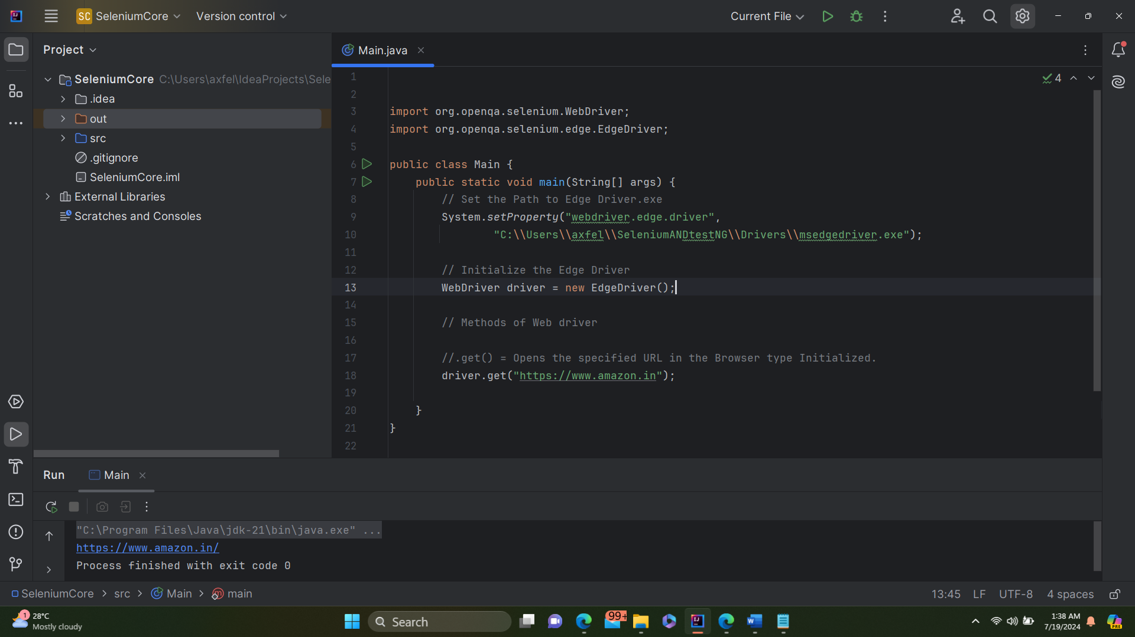

Output

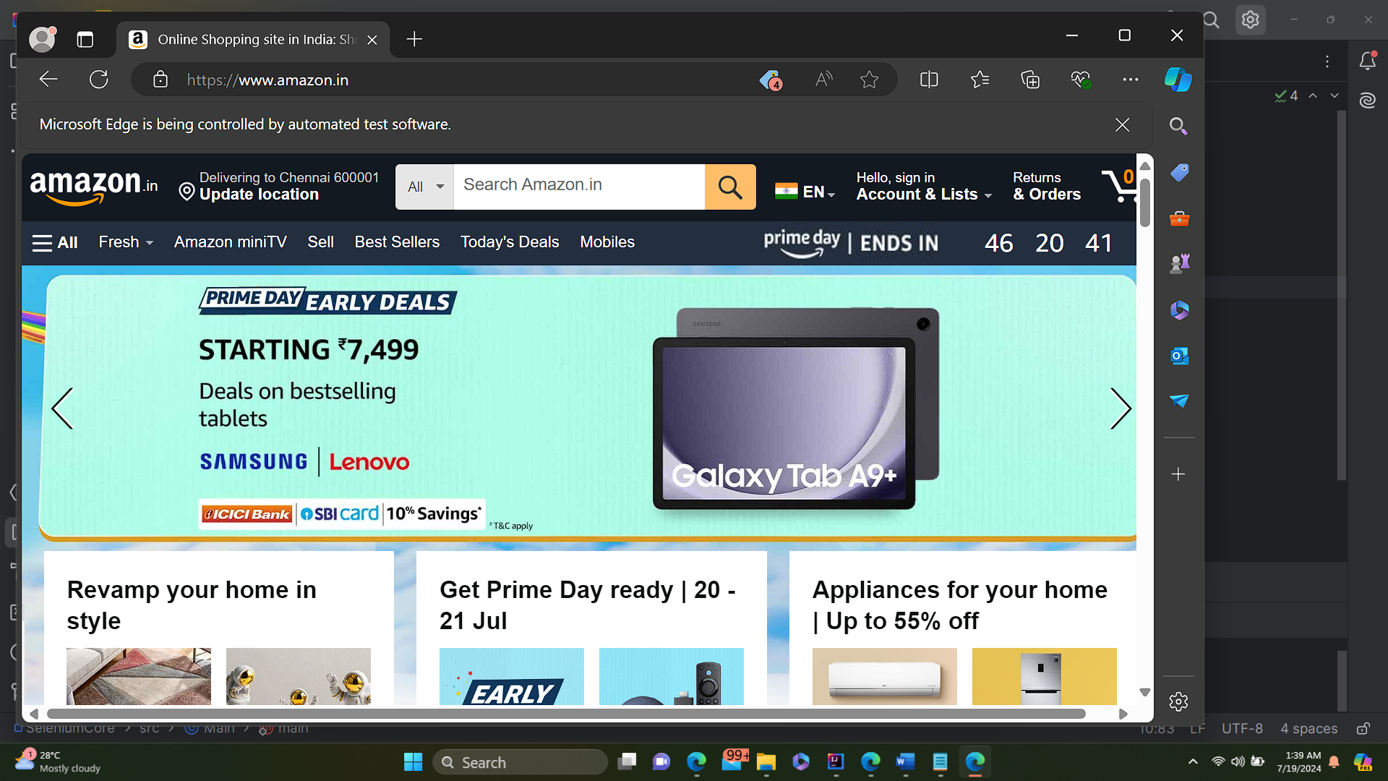

//.getCurrentUrl() = Get the url of the website opened.

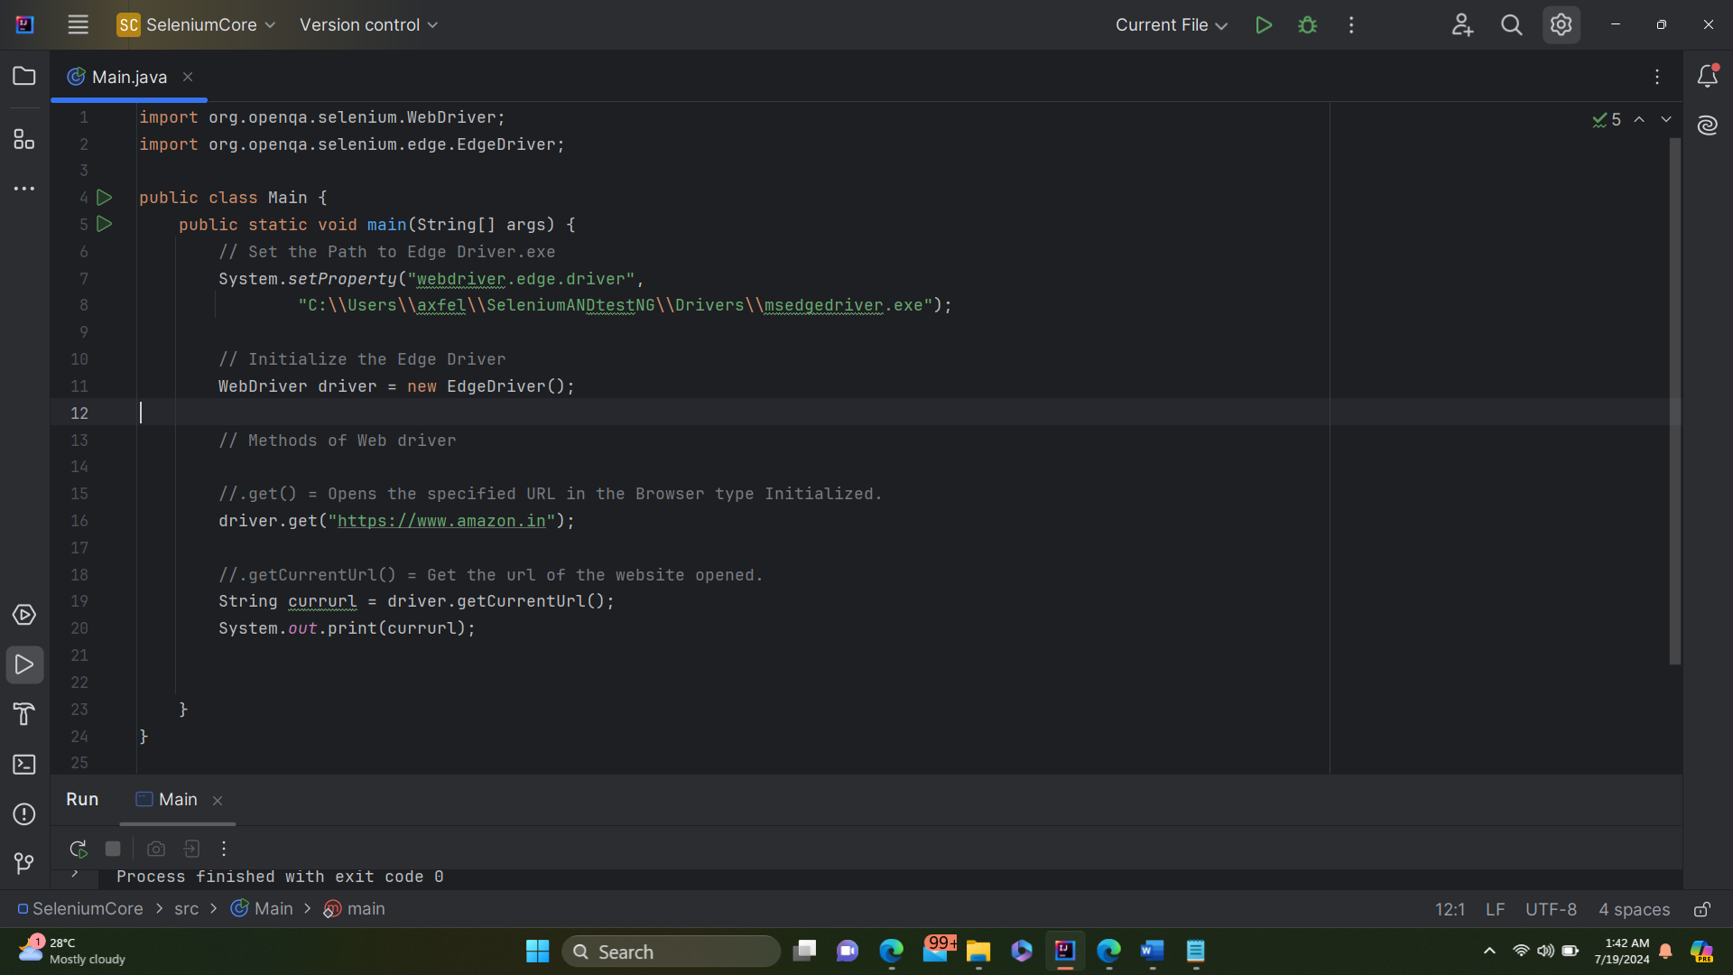

Output

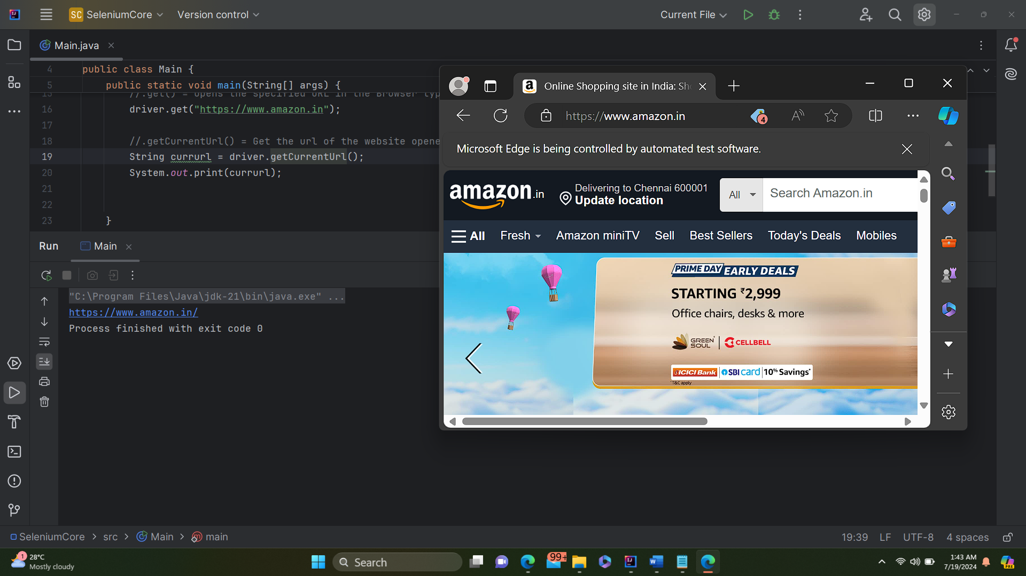

.getPageSource() = Gets the complete page source of the web page opened.

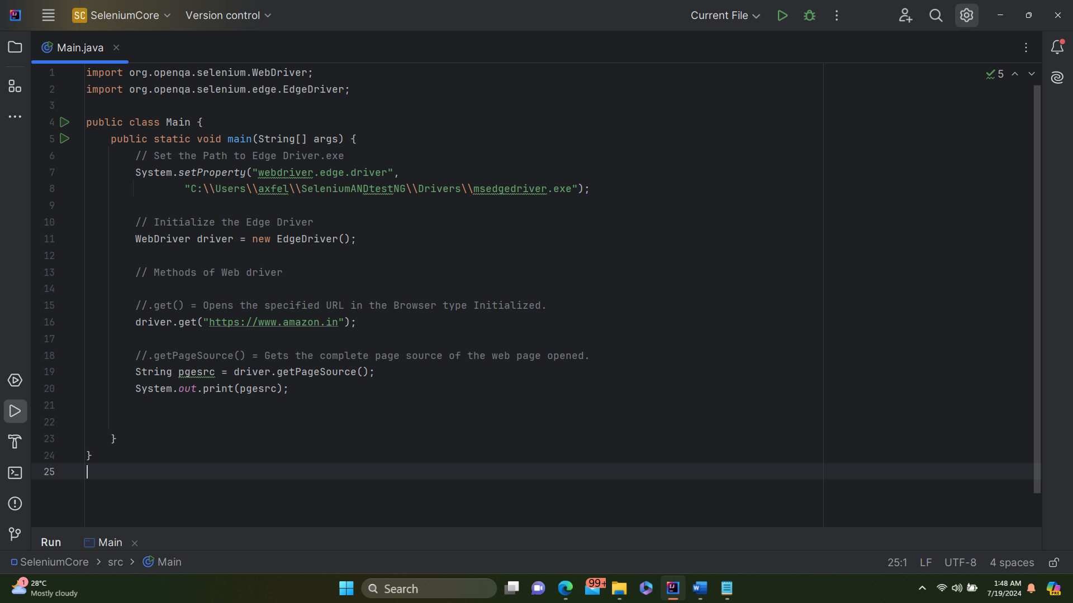

Output

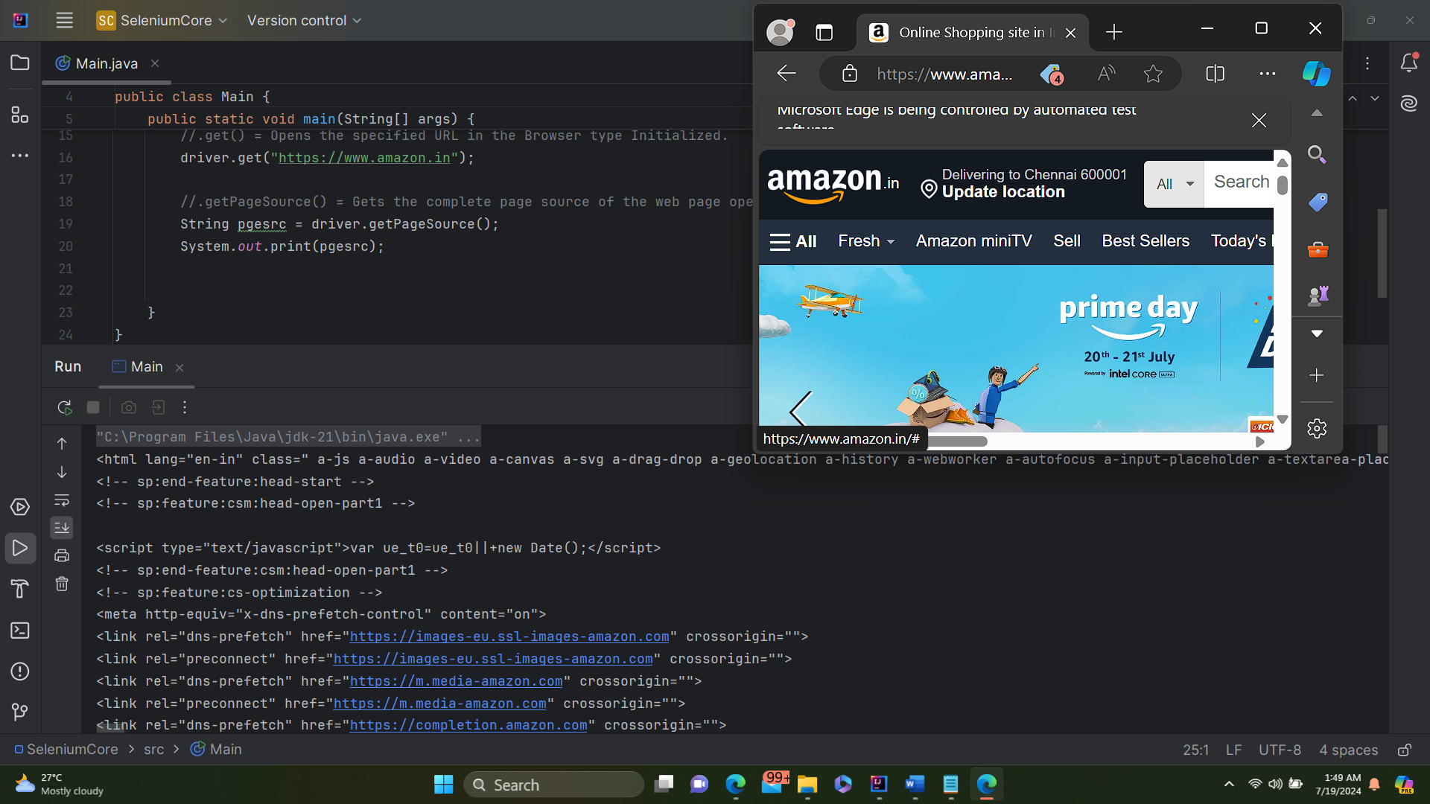

. getTitle() = Gets the title of the web page opened

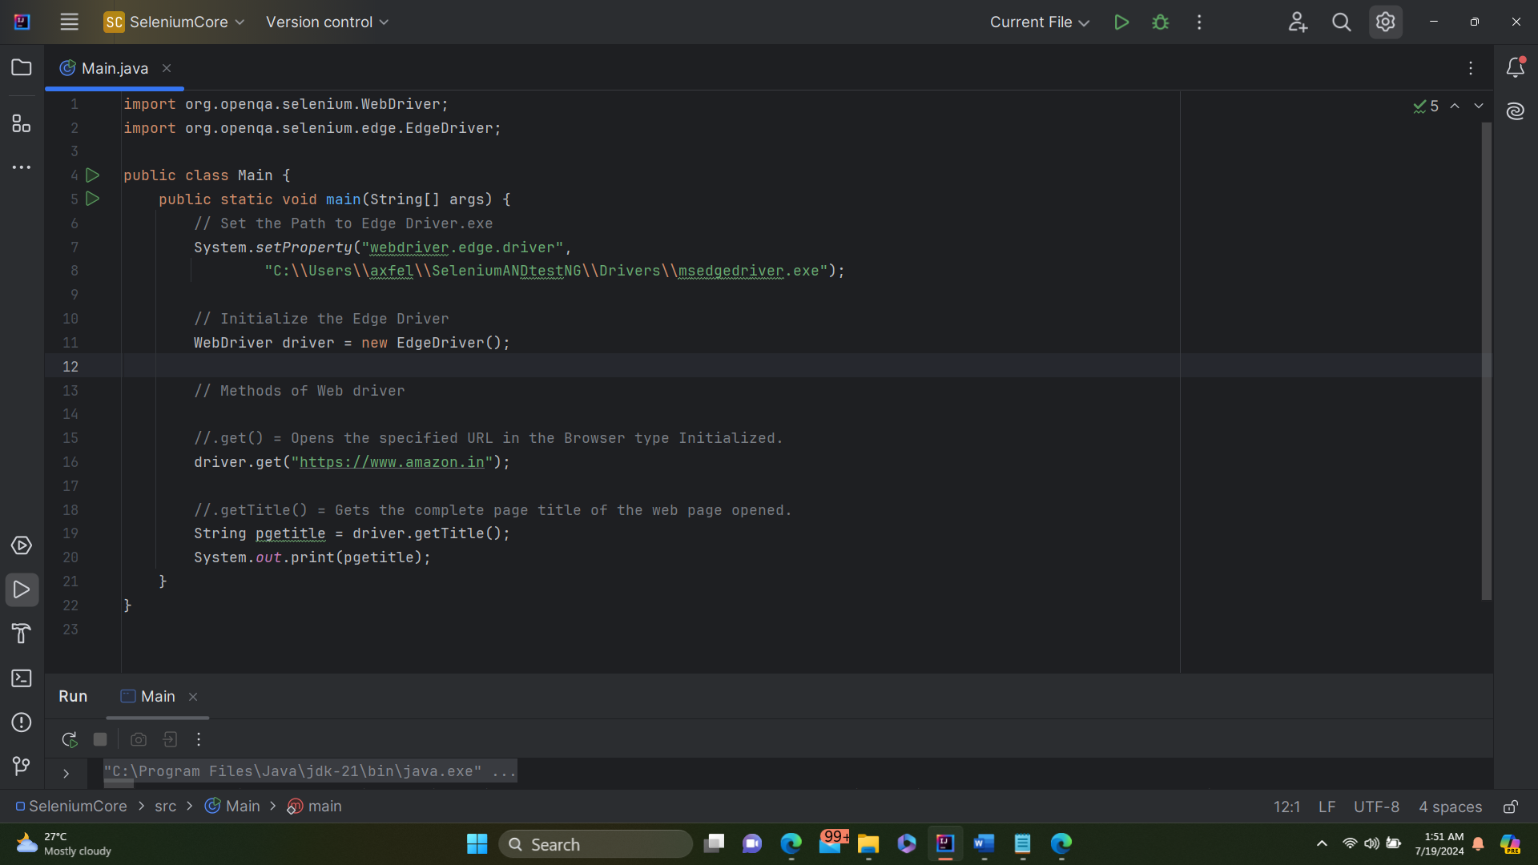

Output:

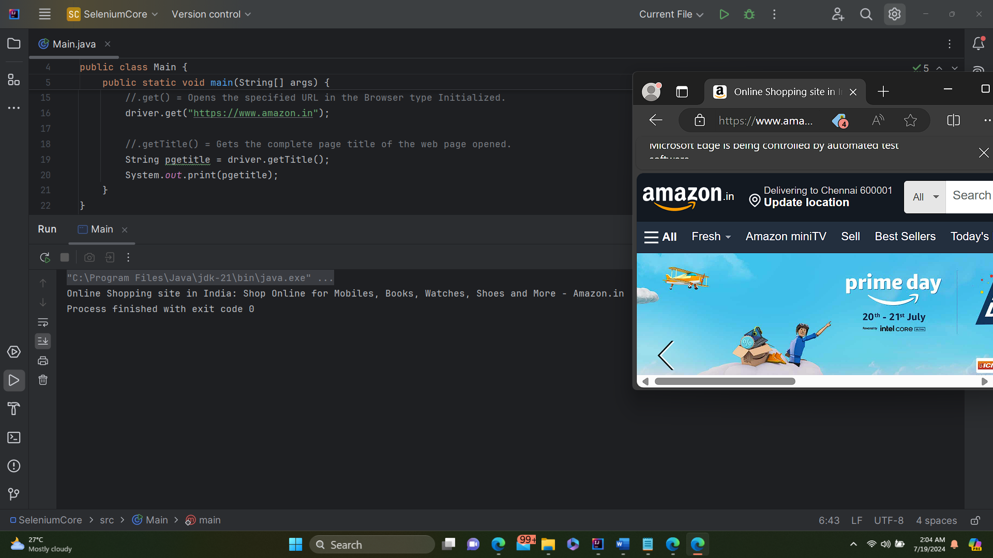

//.getWindowHandle() = Gets the window handle id of the web page opened.

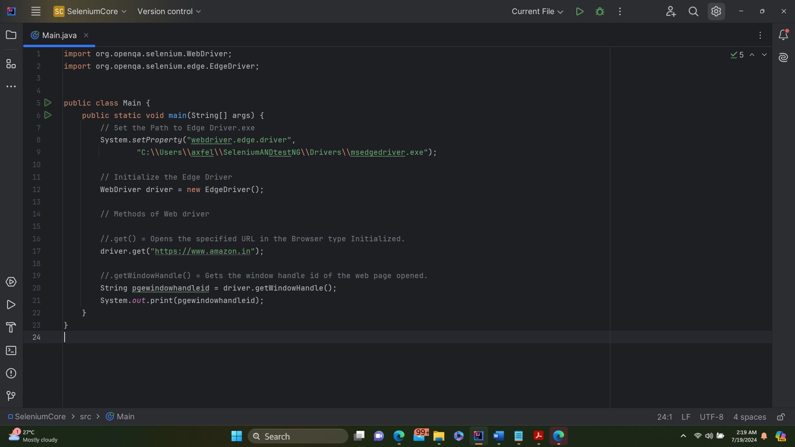

Output

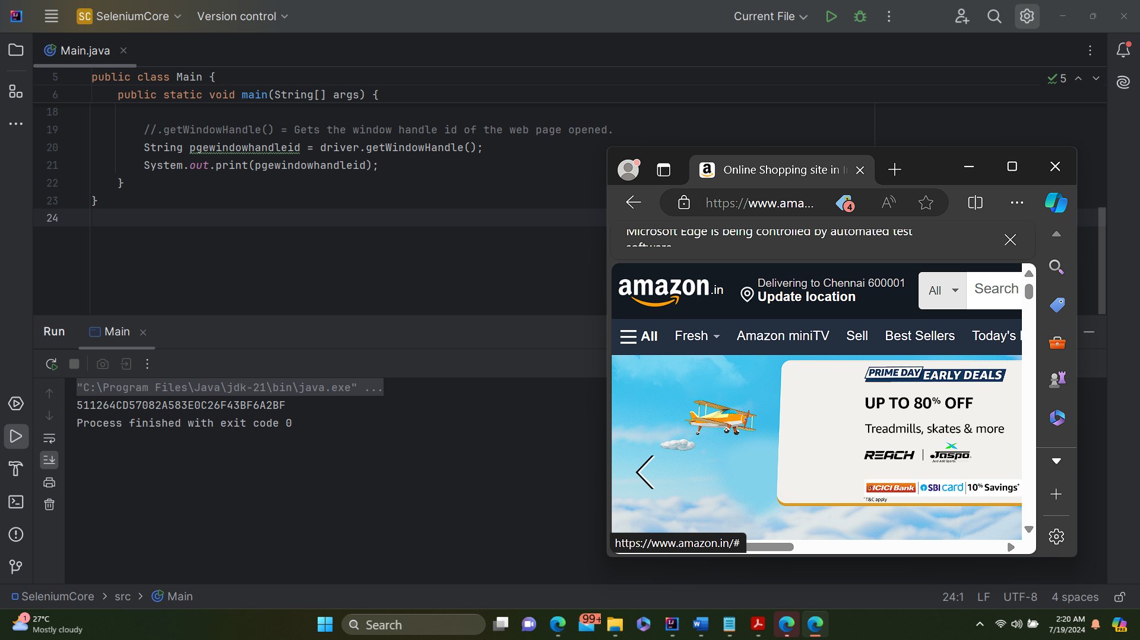

//.getWindowHandles() = Gets the window handle id of all the open tabs within the browser.

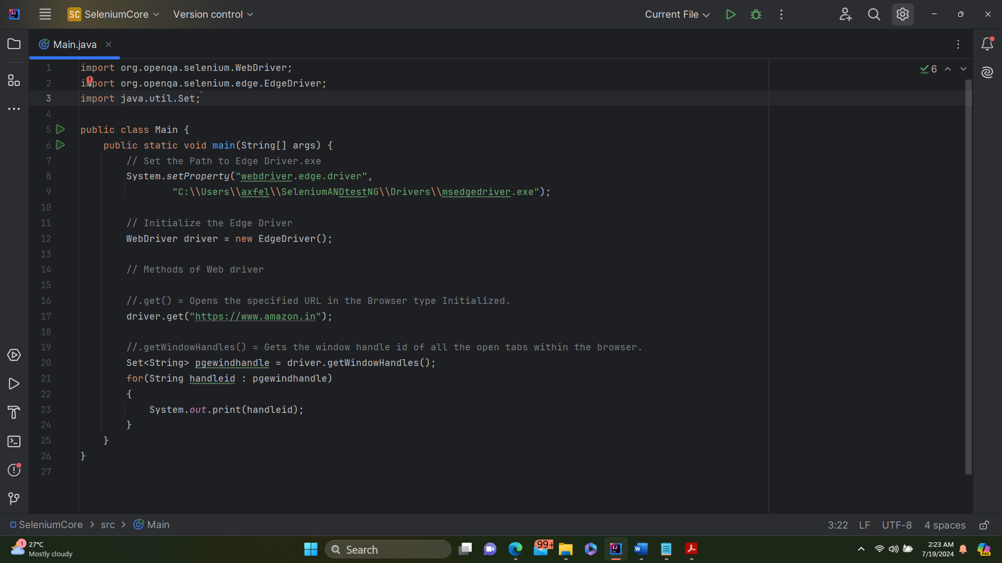

Output

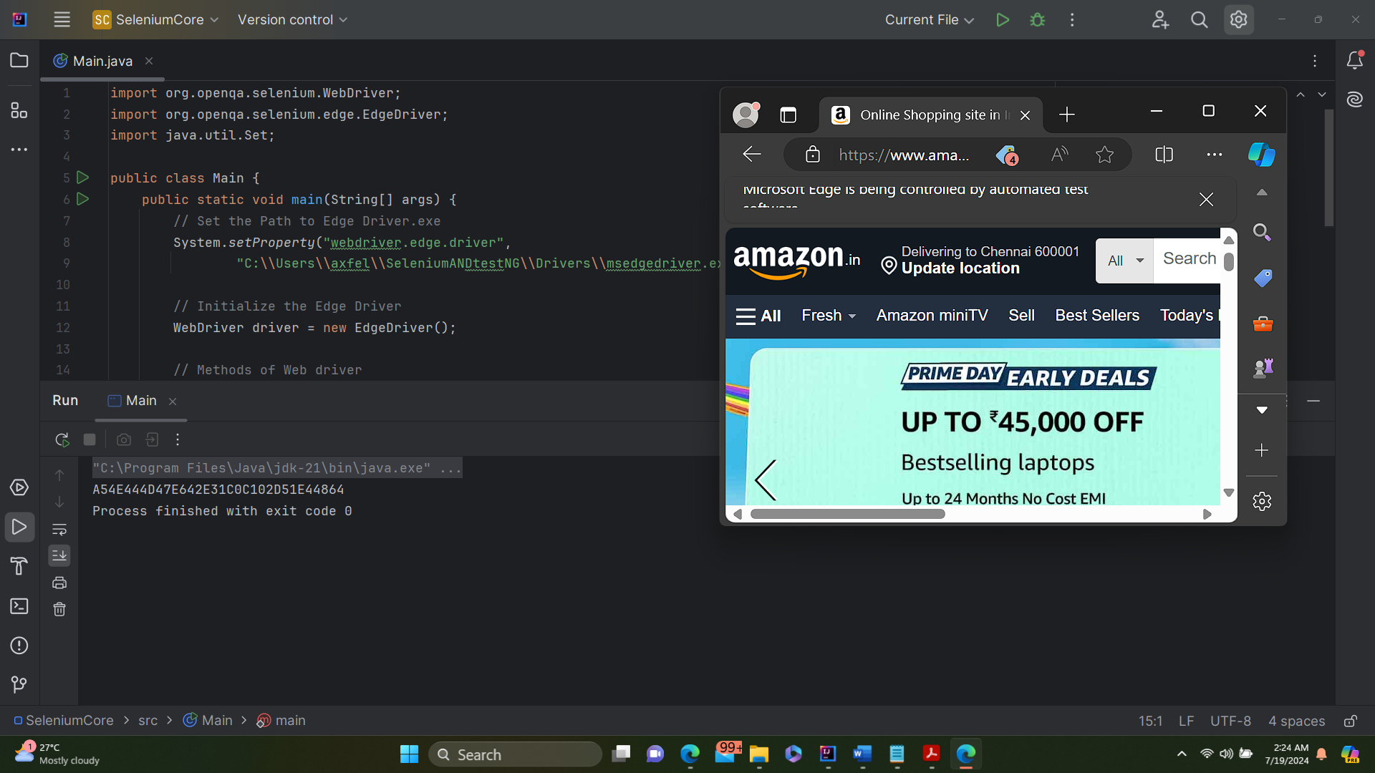

**driver.close()**

* **Functionality**: Closes the current browser window or tab that the WebDriver is controlling.
* **Scope**: Only the window or tab in focus is closed. If multiple windows or tabs are open, only the one that is currently active will be closed.
* **Usage**: Useful when you need to close a specific window or tab without terminating the entire WebDriver session.

**driver.quit()**

* **Functionality**: Closes all the browser windows or tabs opened by the WebDriver and terminates the WebDriver session.
* **Scope**: The entire WebDriver session is terminated, including all browser windows or tabs opened during the session.
* **Usage**: Ideal when you want to end the WebDriver session completely and release all associated resources.

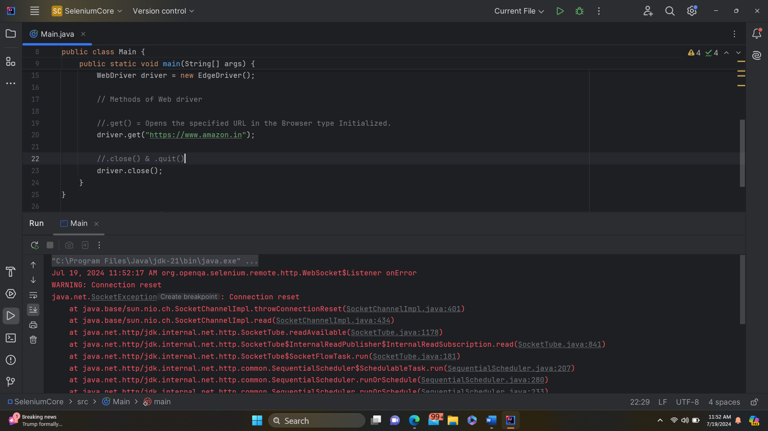

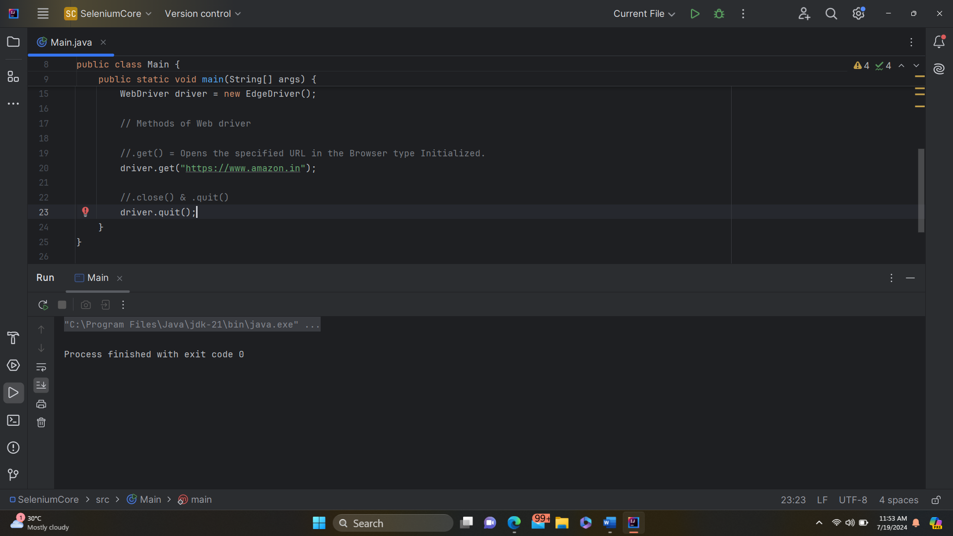

* Navigate()
  + Back()
  + Forward()
  + To()
  + Refresh()

Driver.get() & driver.navigate().to acts same , but there is a difference.

Driver.get() = waits for the page to fully load and then only pass the control to the next line in the code.

driver.navigate().to = Naturally does not wait for the page to load fully and concentrates on the navigation alone. Once the navigation action is executed, the control moves to the next line.

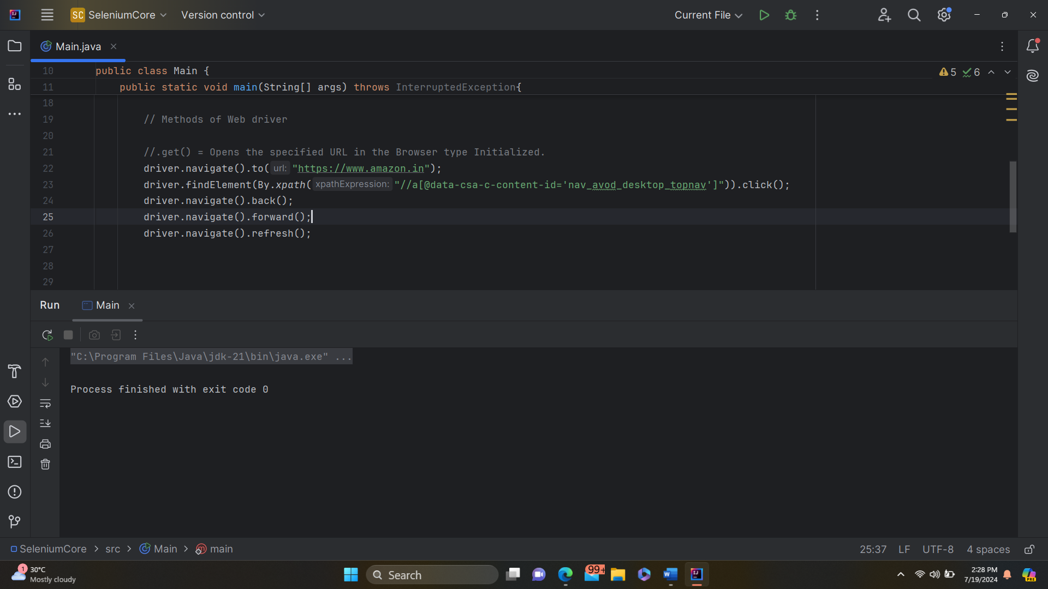

* + Window()
    - Fullscreen()
    - Getposition()
    - Getsize()
    - Maximize()
    - Minimize()
    - Setposition()
    - Setsize()

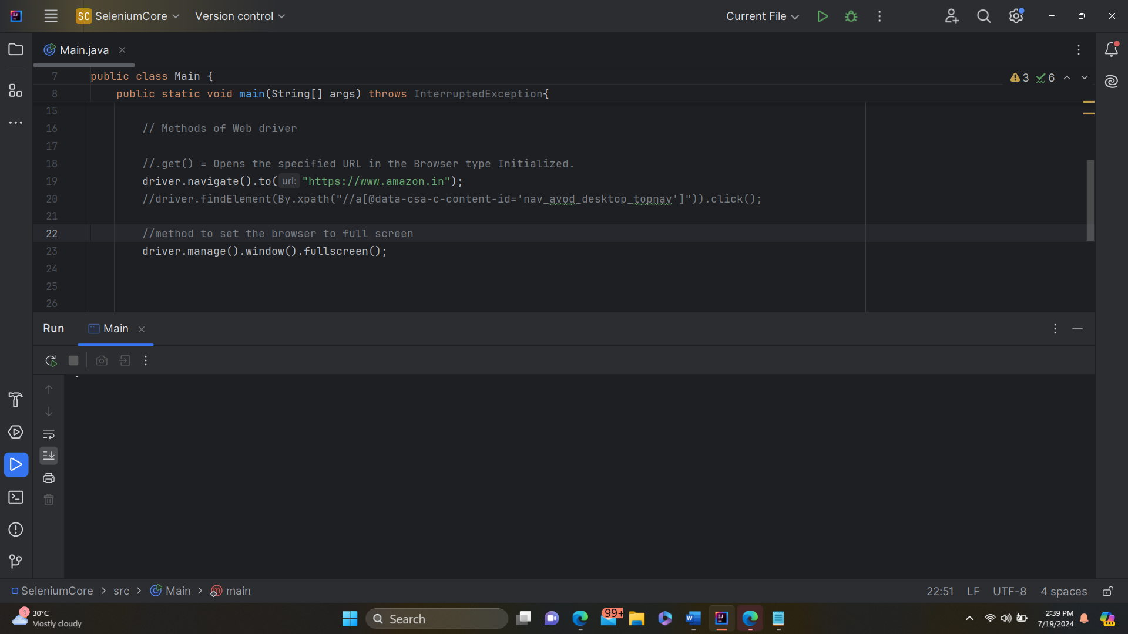

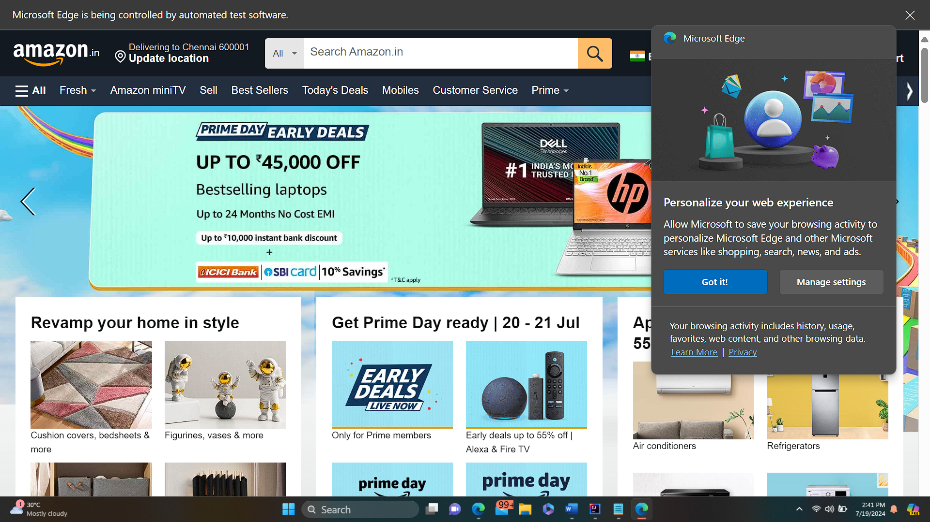

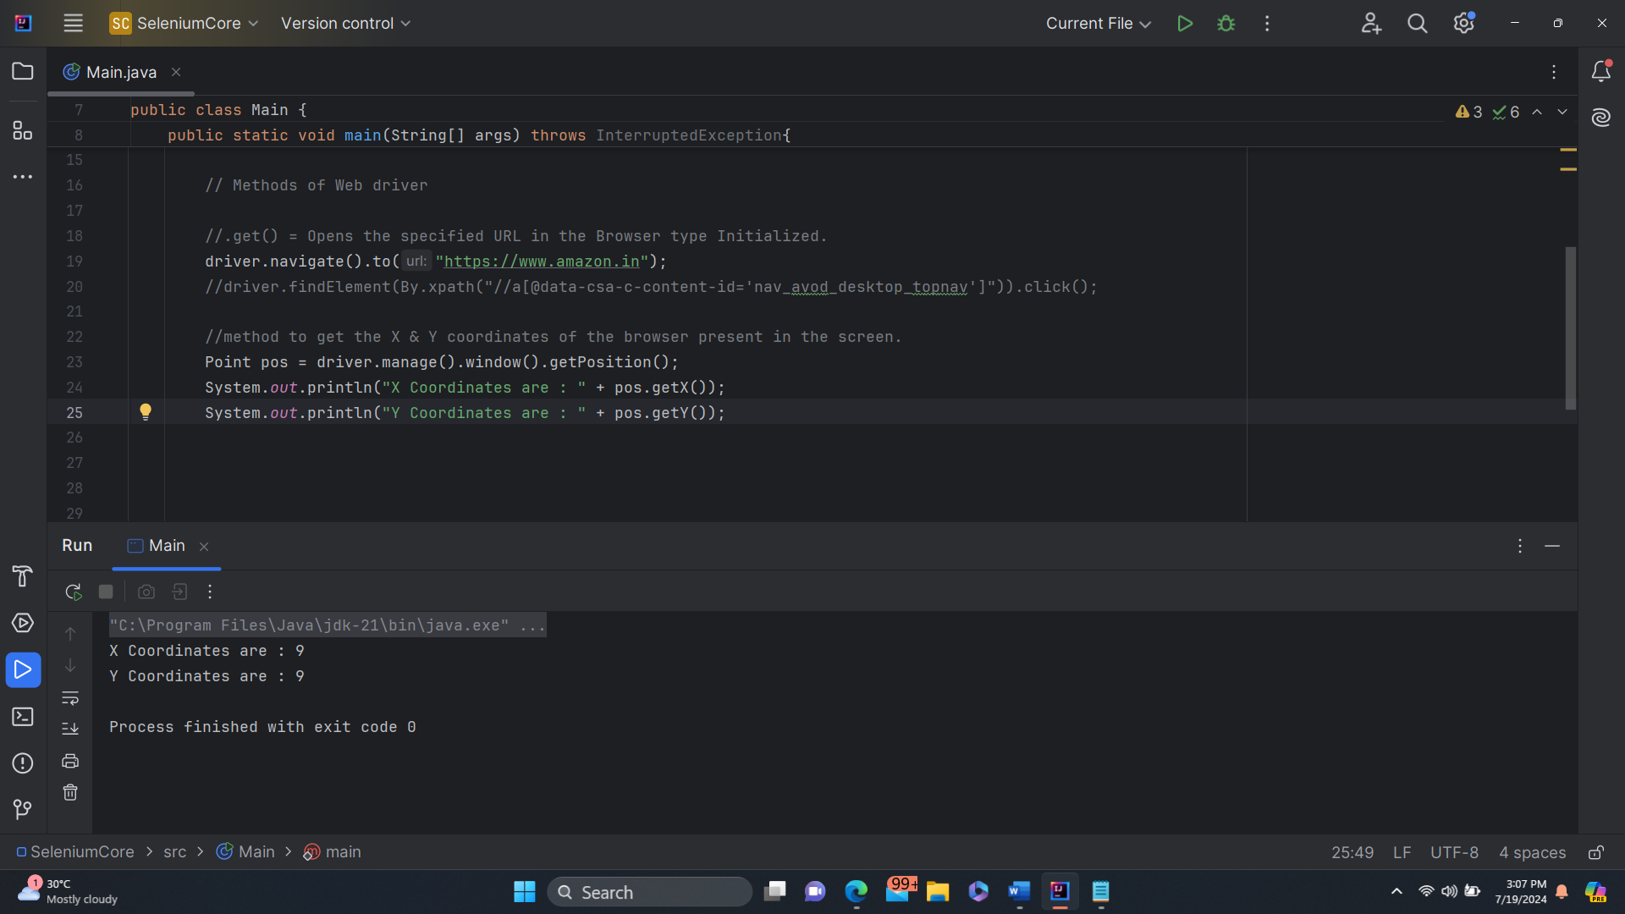

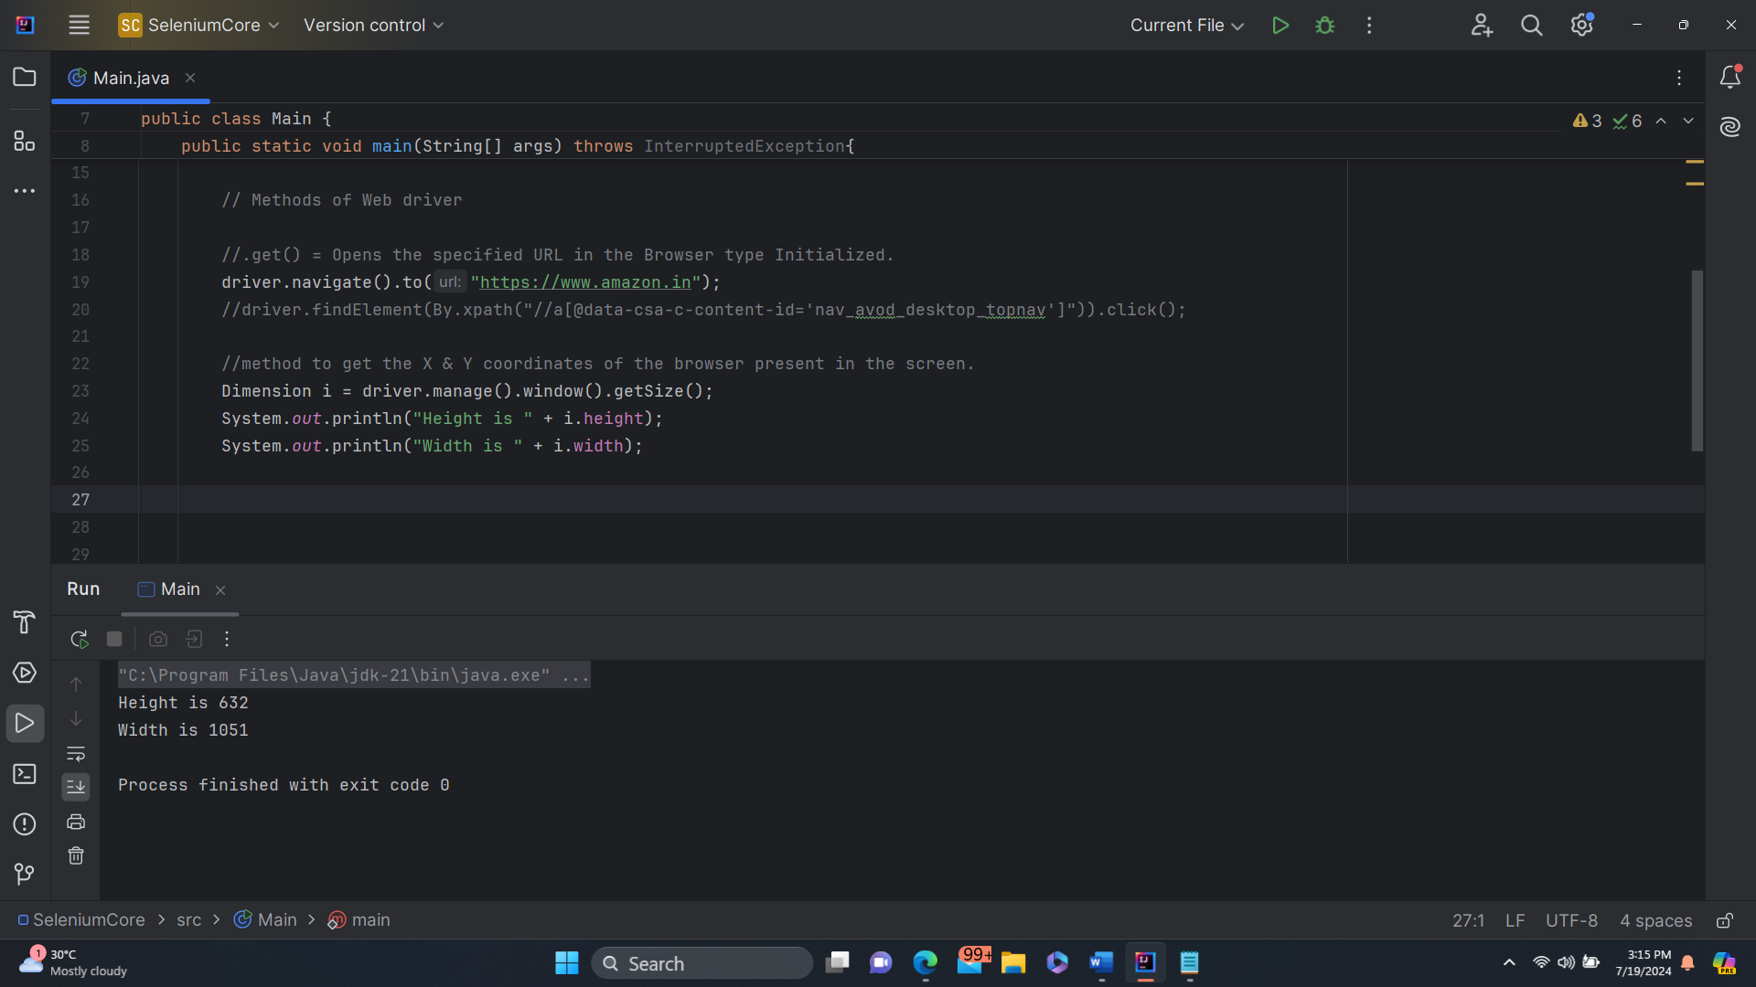

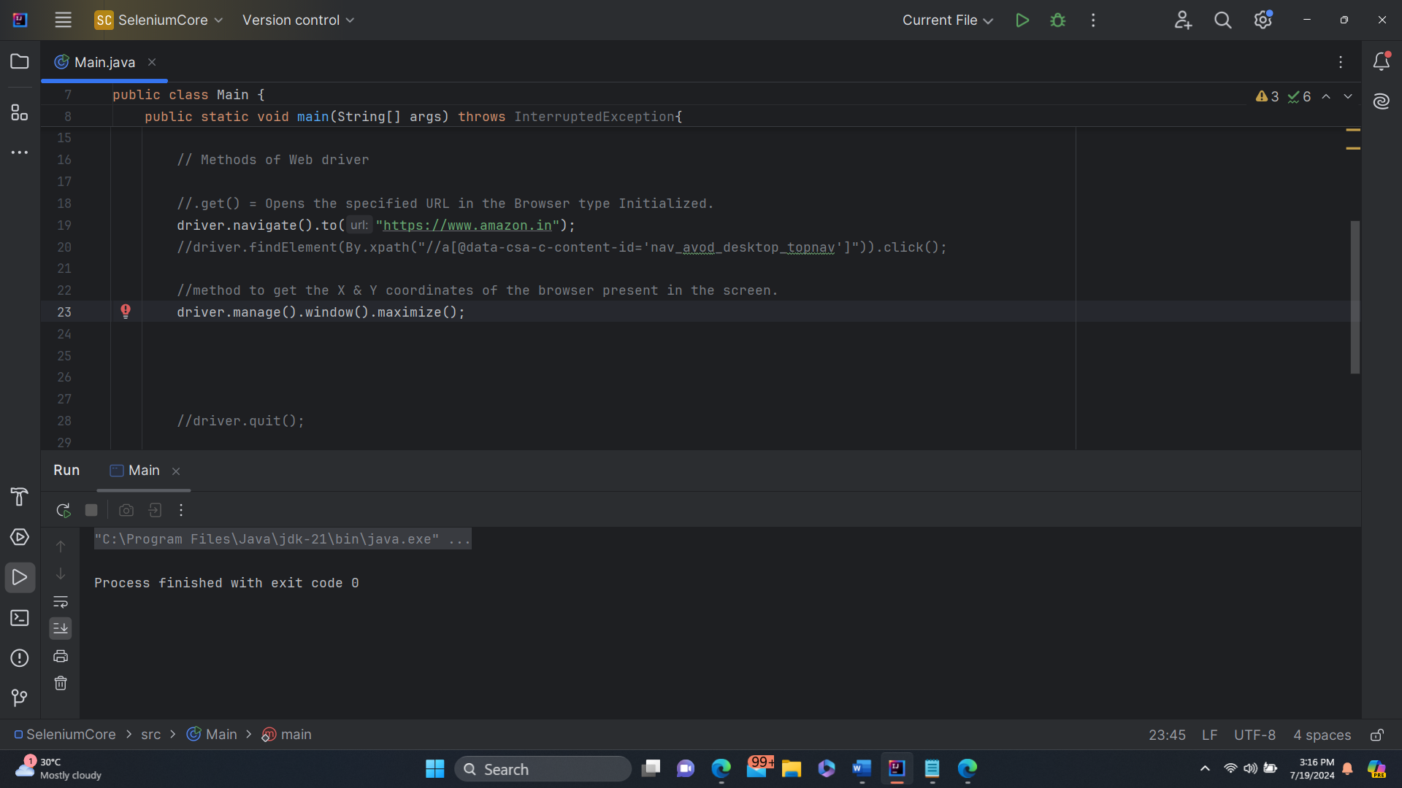

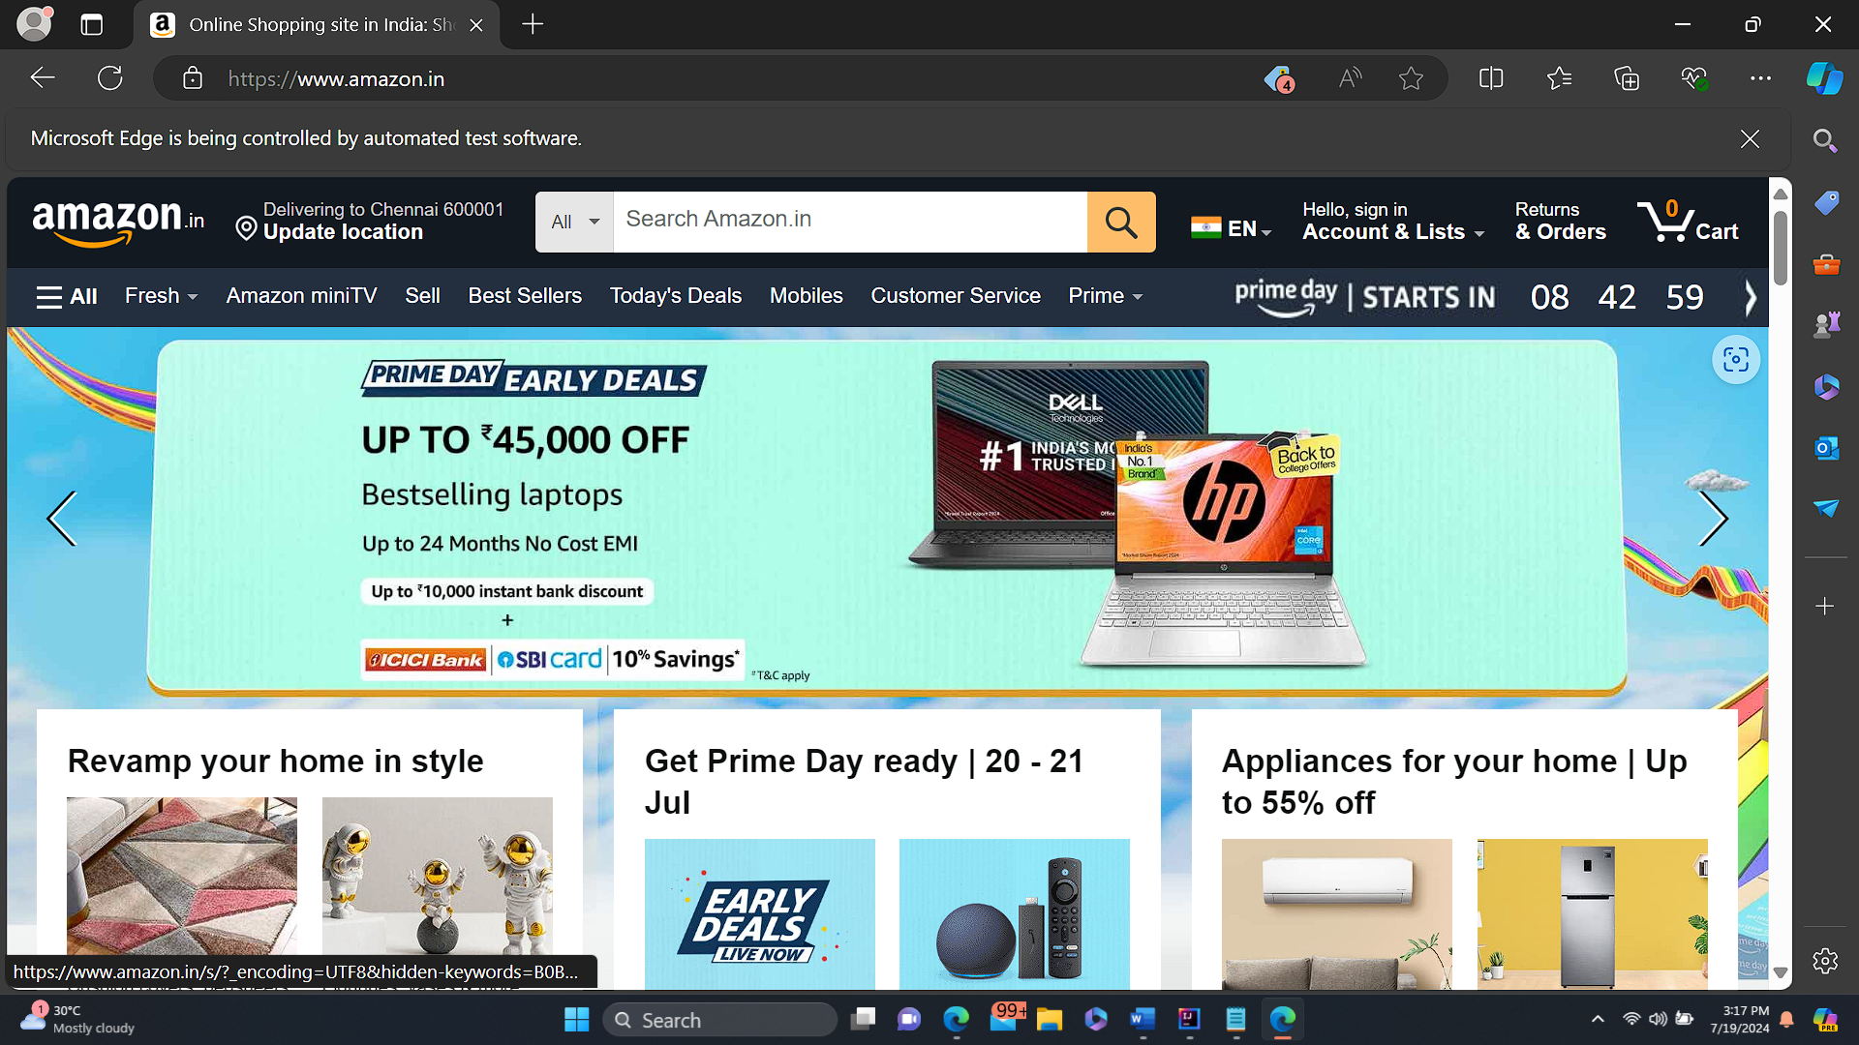

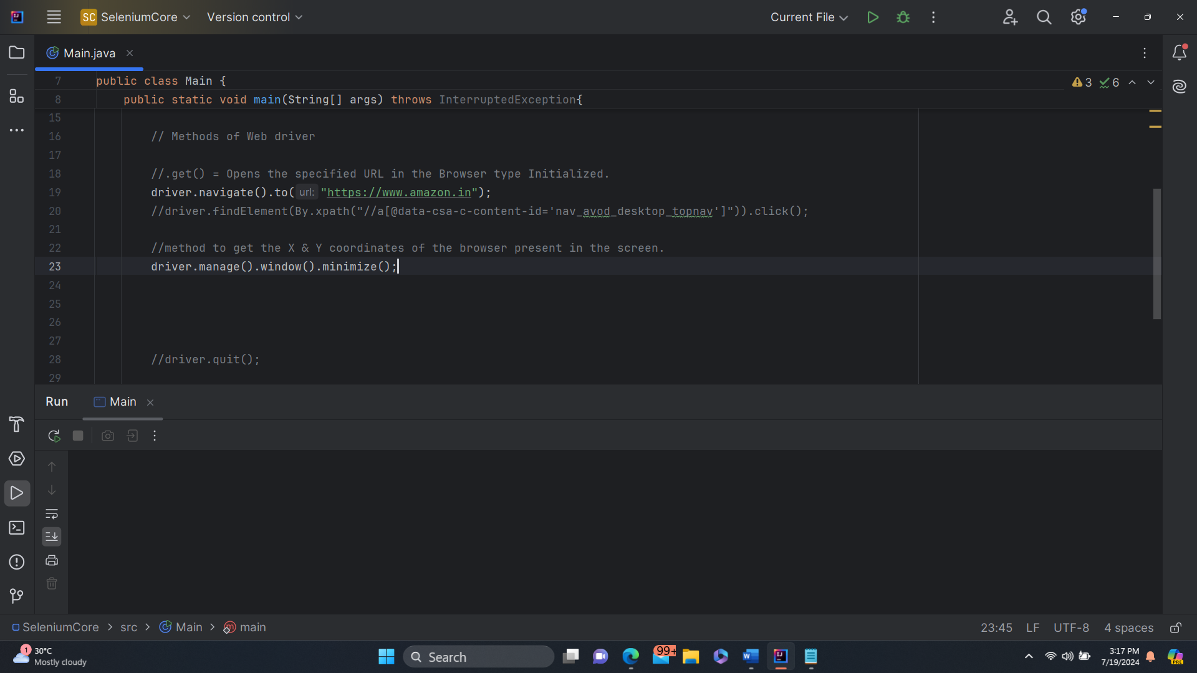

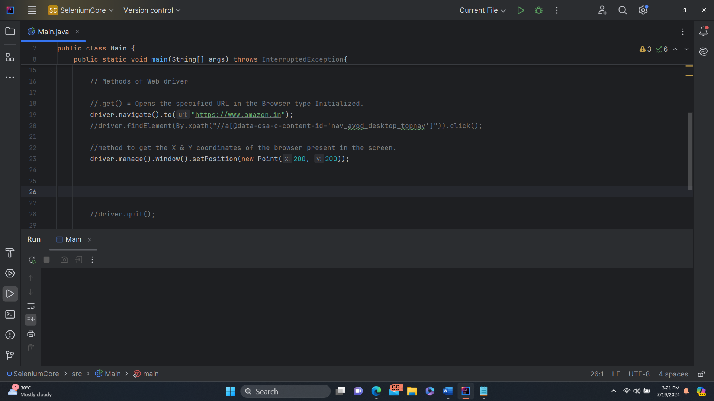

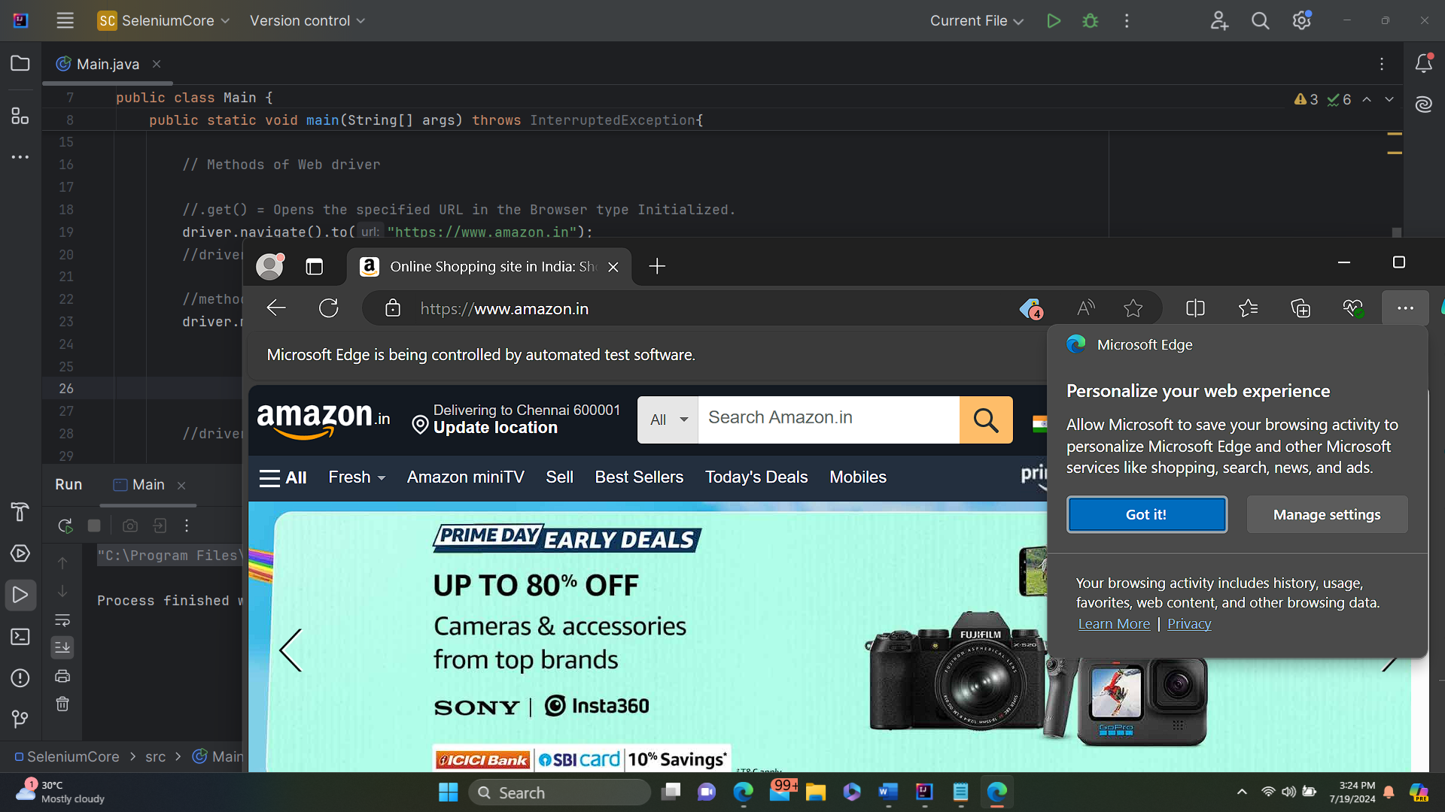

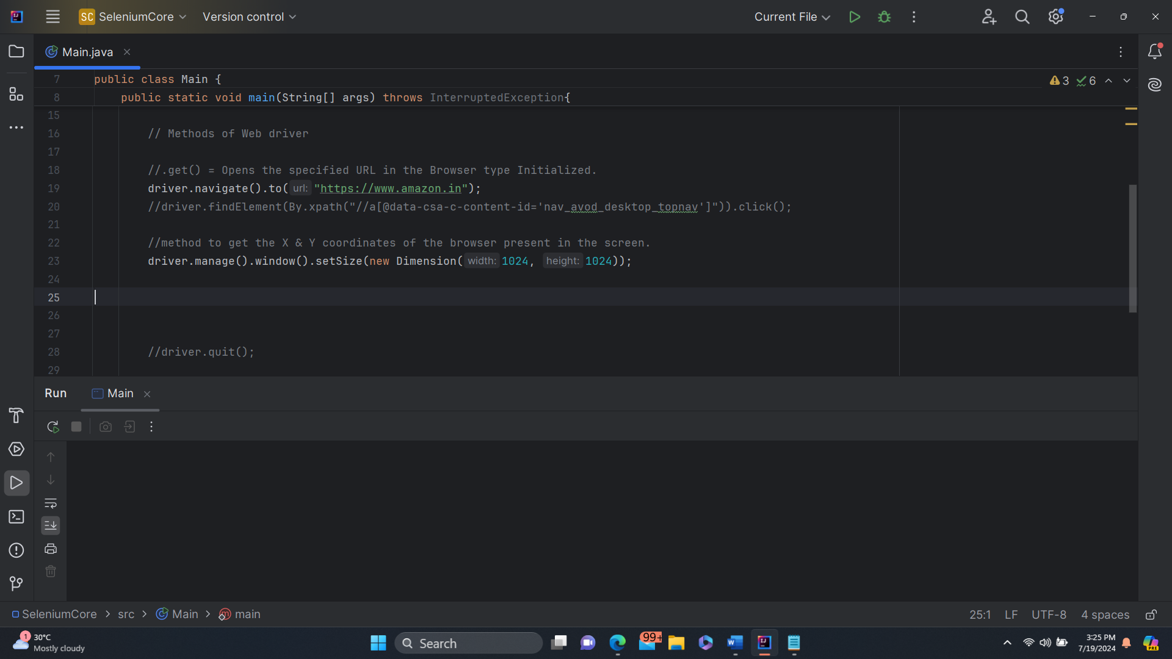

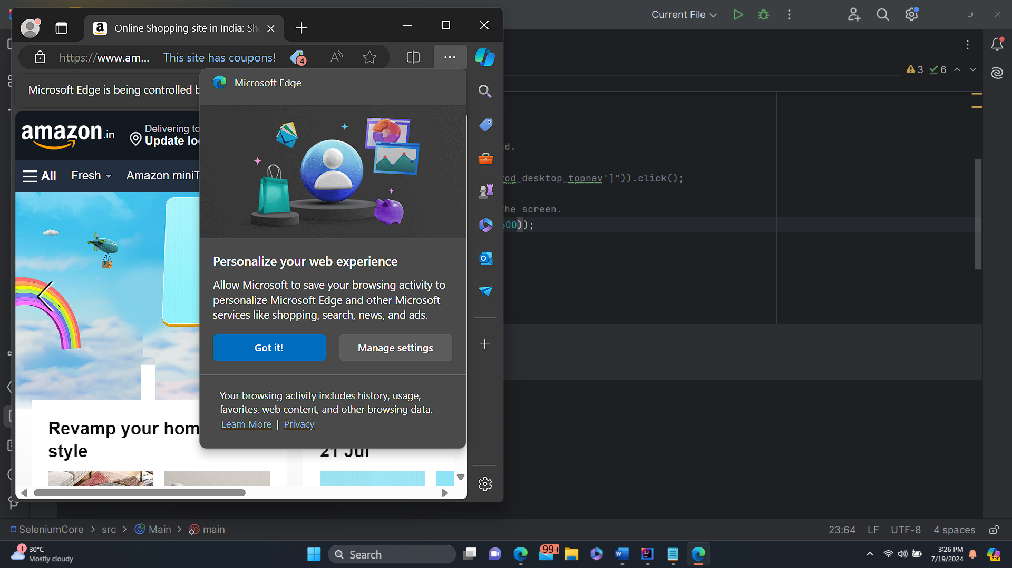

* + Timeouts()
    - Getimplicitwaittimeout()
    - Getscripttimeout
    - Getpageloadtimeout()
    - Implicitlywait()
    - Pageloadtimeout()
    - Scripttimeout()

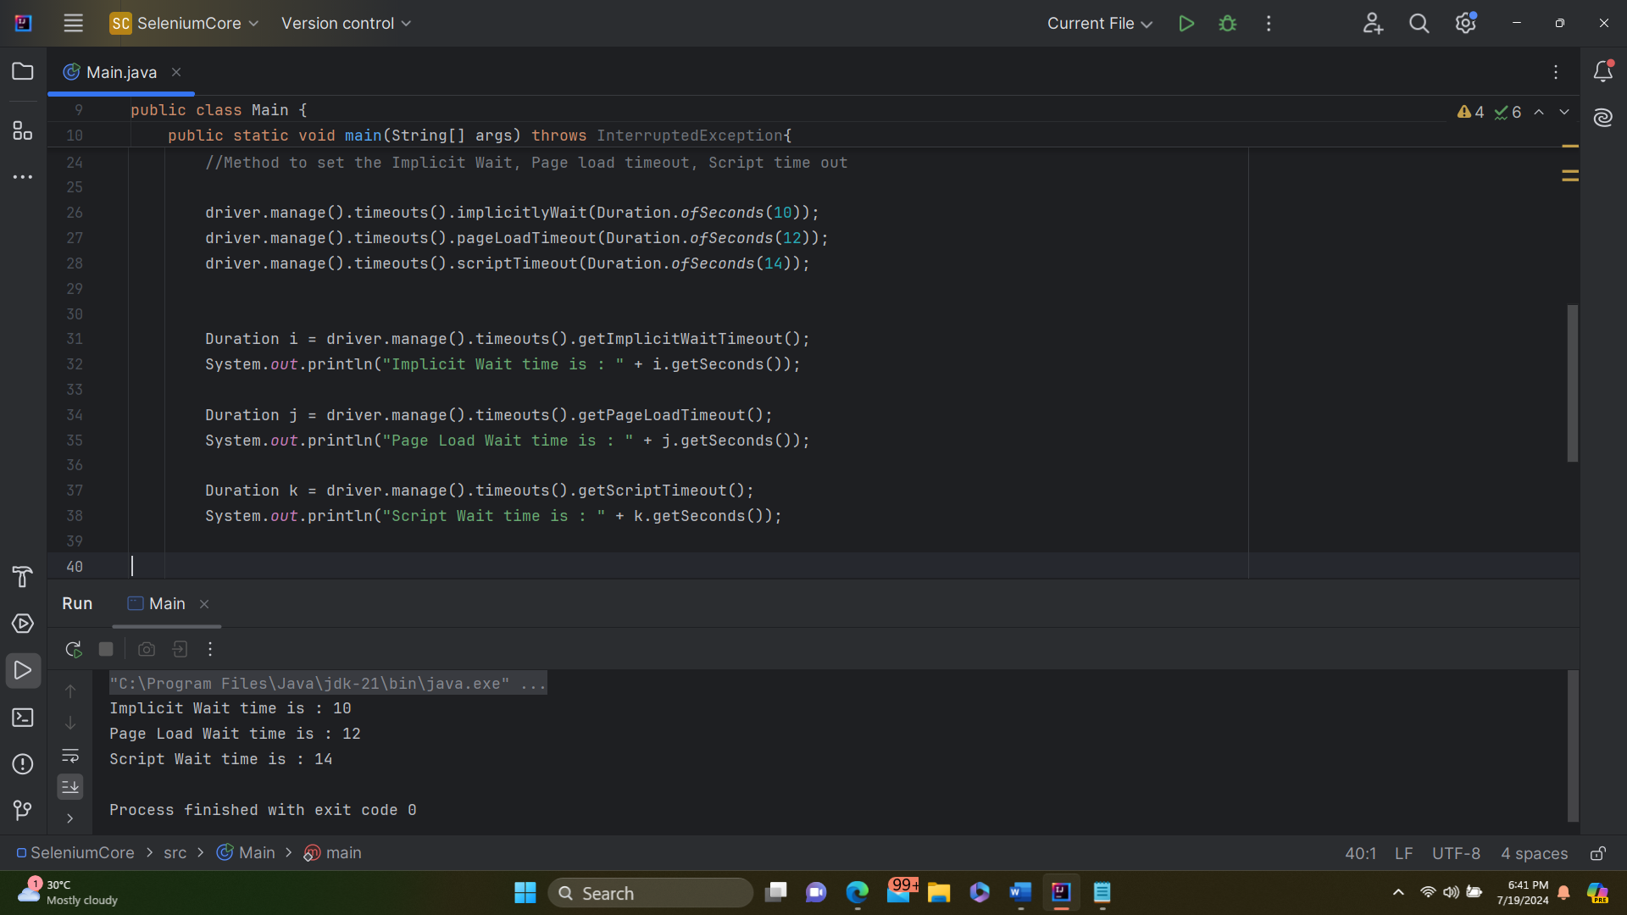

FYI – Cookies related Methods and Logs related methods are ignored as of now due to time constraint and they are not used currently as well. But it need to be explored when ever you get some time.

Xpath:-

Xpath Locators

* 1. ID, Name, Class Name, Link Text, Partial Link Text, Xpath, CSS Path.
  2. Contains
  3. Text
  4. Using OR , AND.
  5. Starts With
  6. Substring
  7. Single dot (.), Double dot (..)
  8. Predicates –

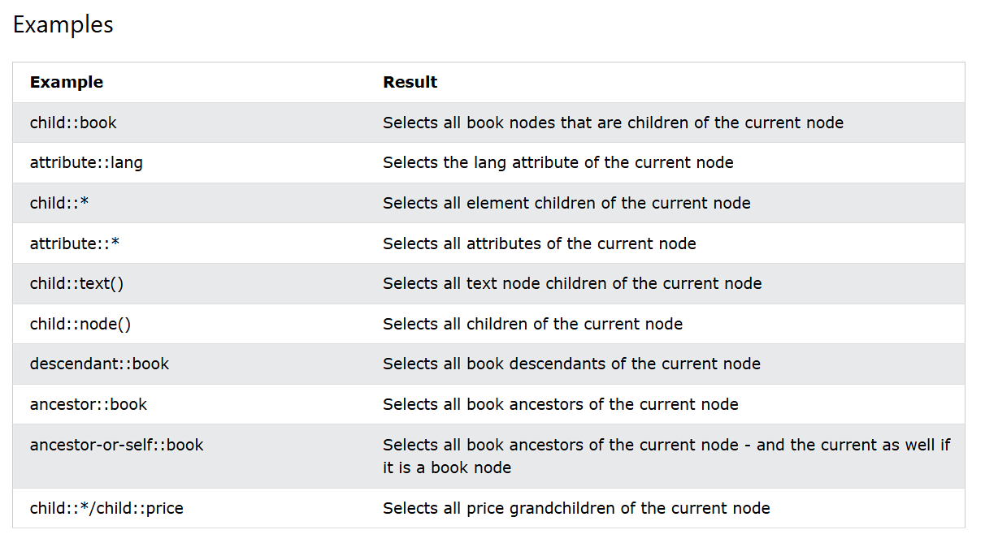

Identfying an element based on locators.

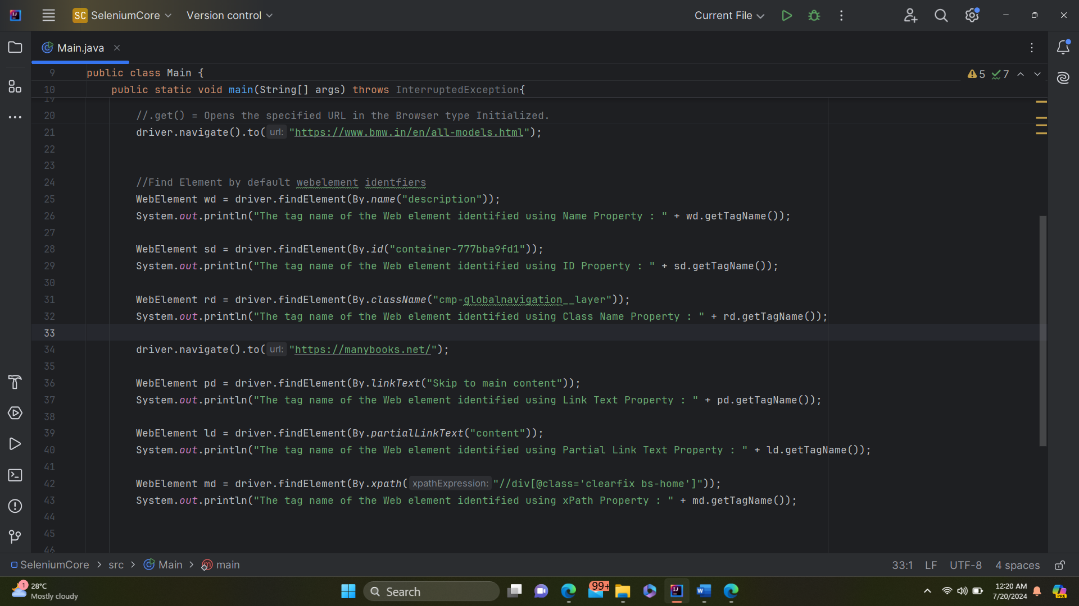

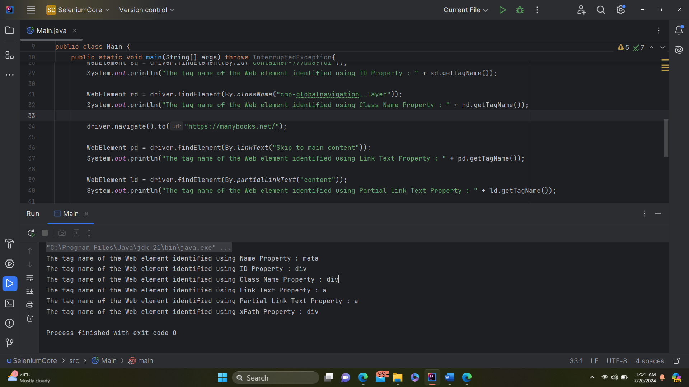

Partial Link text requires the part of a visible text of the tag, where as the link text requires the exact value of the visible text of the tag.

Code copy

import org.openqa.selenium.*;  
import org.openqa.selenium.edge.EdgeDriver;  
import org.openqa.selenium.support.ui.Wait;  
  
import java.time.Duration;  
import java.util.Set;  
import java.util.concurrent.TimeUnit;  
  
public class Main {  
 public static void main(String[] args) throws InterruptedException{  
 // Set the Path to Edge Driver.exe  
 System.*setProperty*("webdriver.edge.driver",  
 "C:\\Users\\axfel\\SeleniumANDtestNG\\Drivers\\msedgedriver.exe");  
  
 // Initialize the Edge Driver  
 WebDriver driver = new EdgeDriver();  
  
 // Methods of Web driver  
  
 //.get() = Opens the specified URL in the Browser type Initialized.  
 driver.navigate().to("https://www.bmw.in/en/all-models.html");  
  
  
 //Find Element by default webelement identfiers  
 WebElement wd = driver.findElement(By.*name*("description"));  
 System.*out*.println("The tag name of the Web element identified using Name Property : " + wd.getTagName());  
  
 WebElement sd = driver.findElement(By.*id*("container-777bba9fd1"));  
 System.*out*.println("The tag name of the Web element identified using ID Property : " + sd.getTagName());  
  
 WebElement rd = driver.findElement(By.*className*("cmp-globalnavigation__layer"));  
 System.*out*.println("The tag name of the Web element identified using Class Name Property : " + rd.getTagName());  
  
 driver.navigate().to("https://manybooks.net/");  
  
 WebElement pd = driver.findElement(By.*linkText*("Skip to main content"));  
 System.*out*.println("The tag name of the Web element identified using Link Text Property : " + pd.getTagName());  
  
 WebElement ld = driver.findElement(By.*partialLinkText*("content"));  
 System.*out*.println("The tag name of the Web element identified using Partial Link Text Property : " + ld.getTagName());  
  
 WebElement md = driver.findElement(By.*xpath*("//div[@class='clearfix bs-home']"));  
 System.*out*.println("The tag name of the Web element identified using xPath Property : " + md.getTagName());  
  
  
  
  
  
  
 driver.quit();  
  
 }  
}

contains(), Text() or [visible text of a tag]

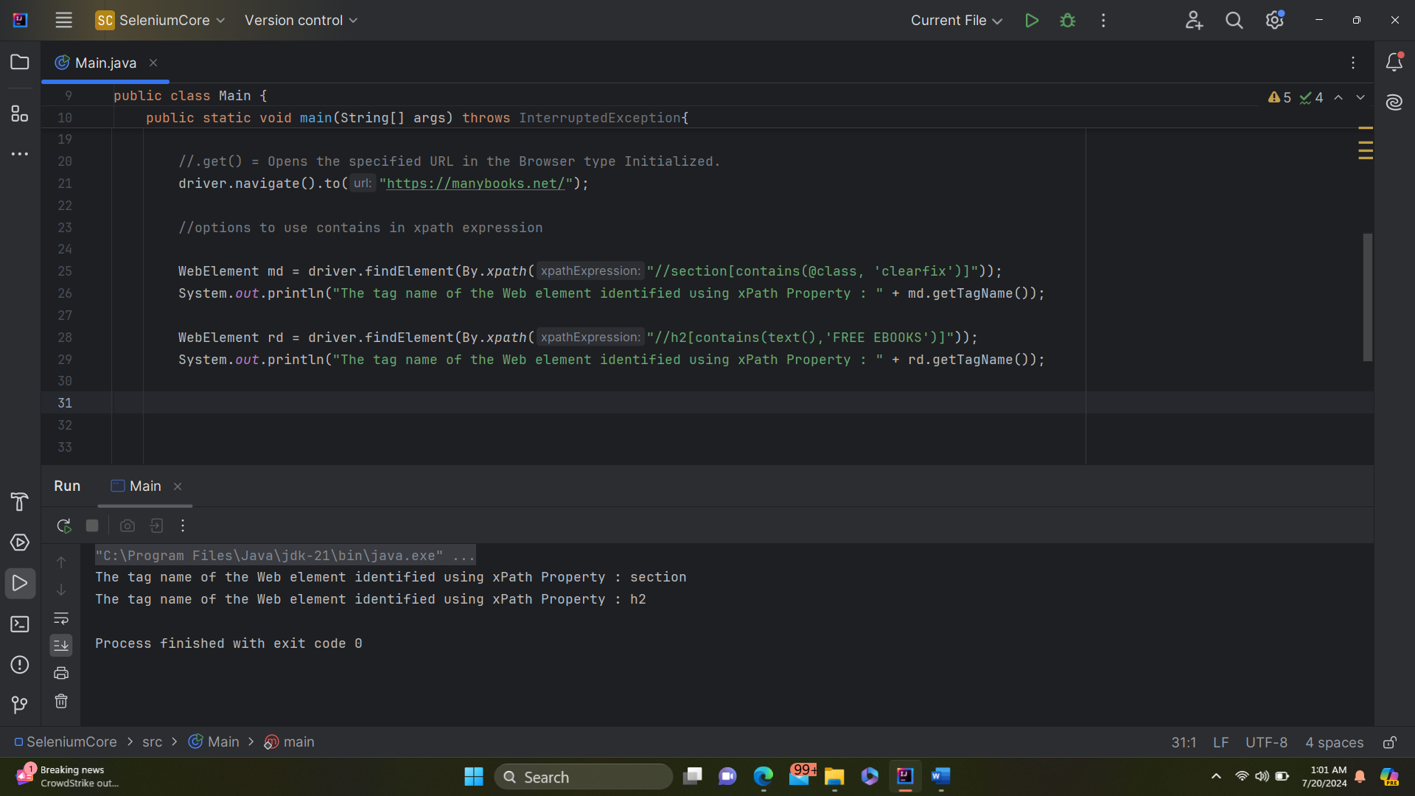

AND , OR in xpath expression

Different ways to use the attributes and its values in a xpath expression with AND

//img[contains(@alt, 'Apple') and (@class='_bXVsd_image_1pfbQ')]

//span[(@class='a-price _bXVsd_price_23Ix_') and (@data-a-size='medium_plus')]

//span[(text()='Limited time deal') and (@data-platform='desktop')]

Different ways to use the attributes and its values in a xpath expression with OR

//img[contains(@alt, 'Apple') or (@class='_bXVsd_image_1pfbQ')]

//span[(@class='a-price _bXVsd_price_23Ix_') or (@data-a-size='medium_plus')]

//span[(text()='Limited time deal') or (@data-platform='desktop')]

Starts with in xpath expression.

//span[starts-with(@data-a-badge-color,'sx')]

//span[starts-with(text(),'Limited')]

In Built functions which are used in X-Path,

String Functions list:

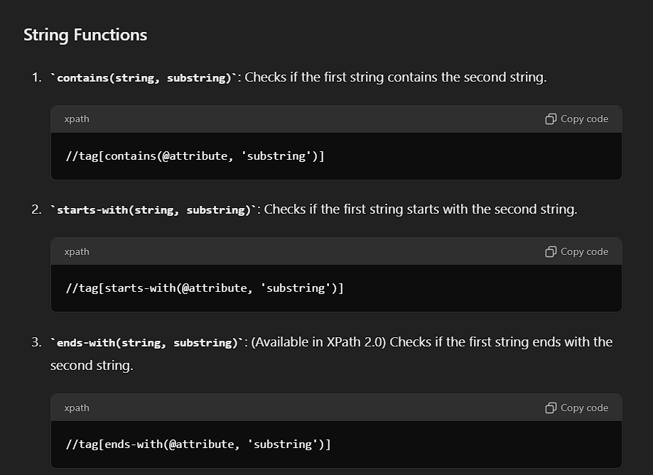

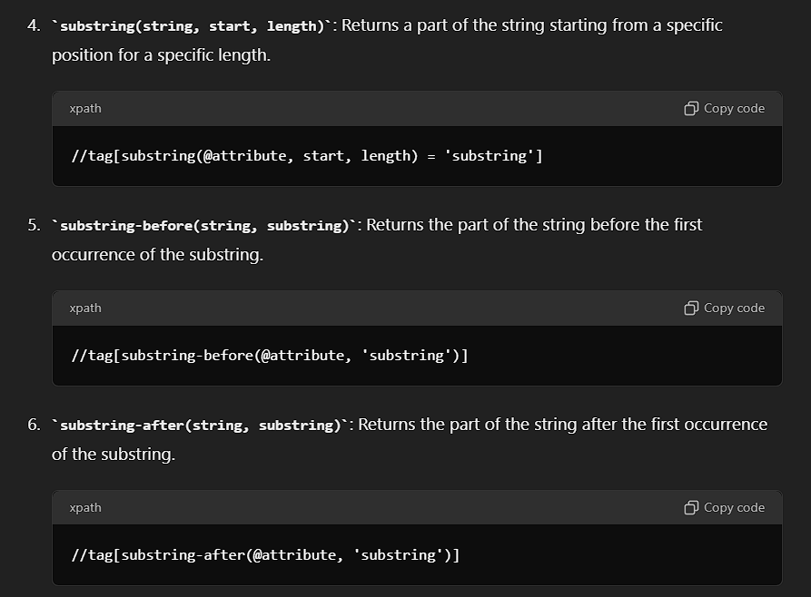

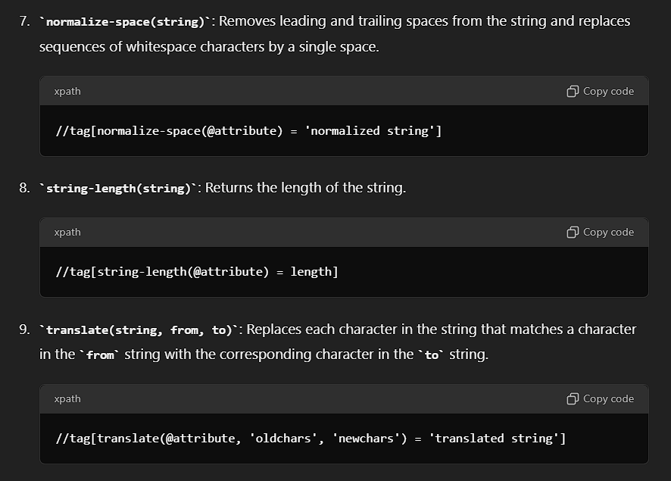

Predicates

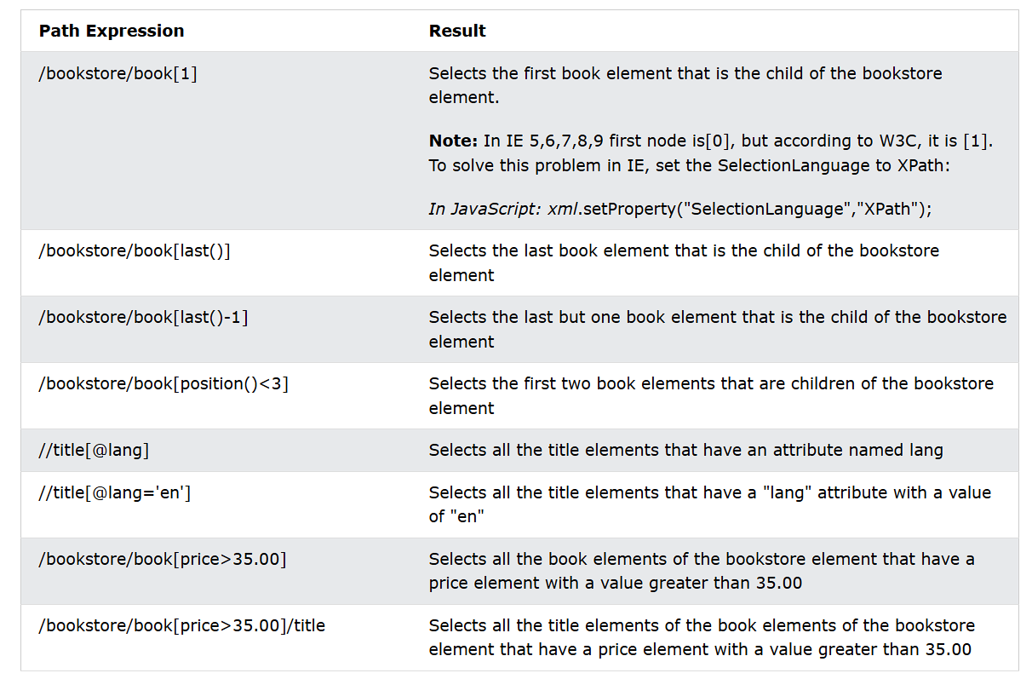

To select the complete xpath based on index, then we can use this way,

(//a[@id='nav-logo-sprites']/span)[1]

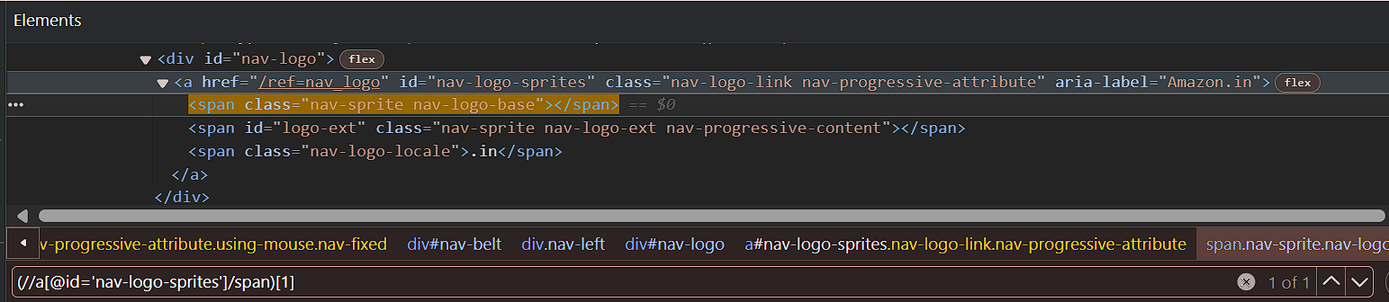

[OR]

//a[@id='nav-logo-sprites']/span[1]

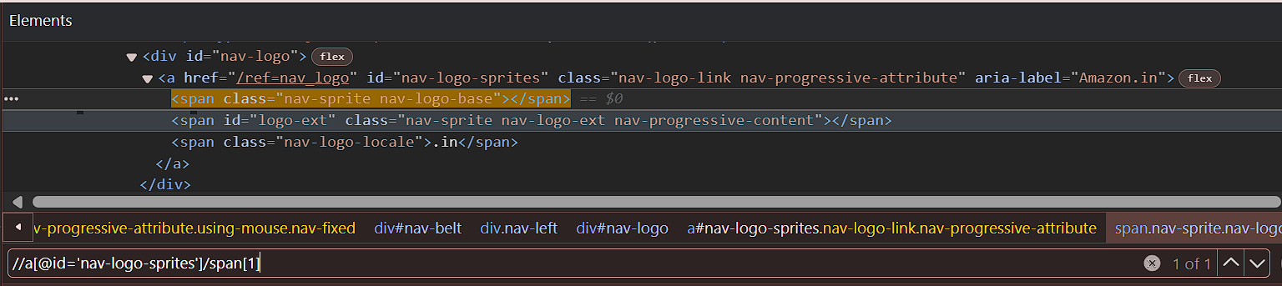

Using last()

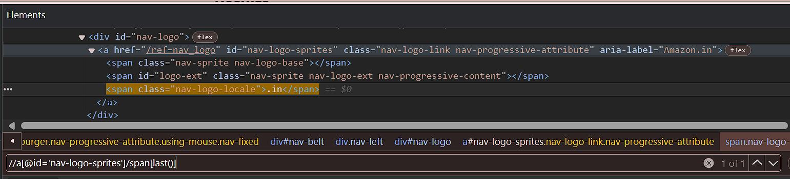

Using last()-1

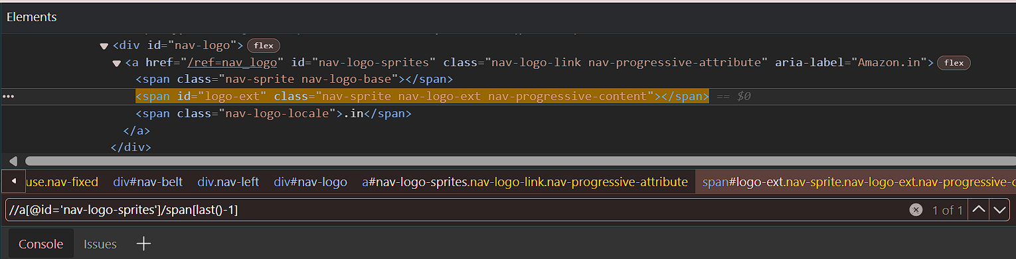

Using Position()

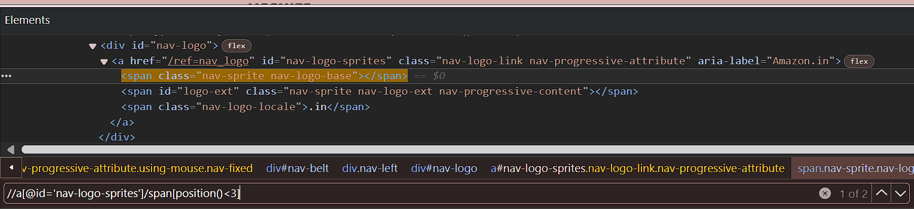

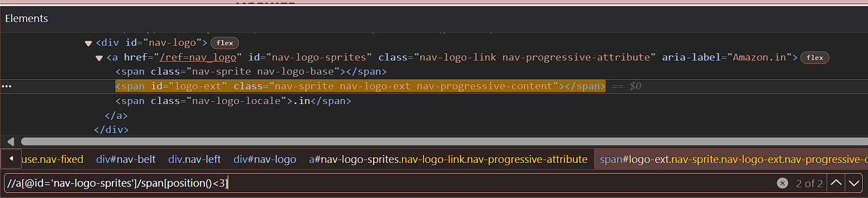

Selecting tags just based on a specific attribute

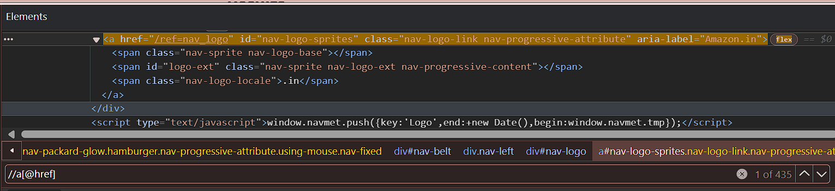

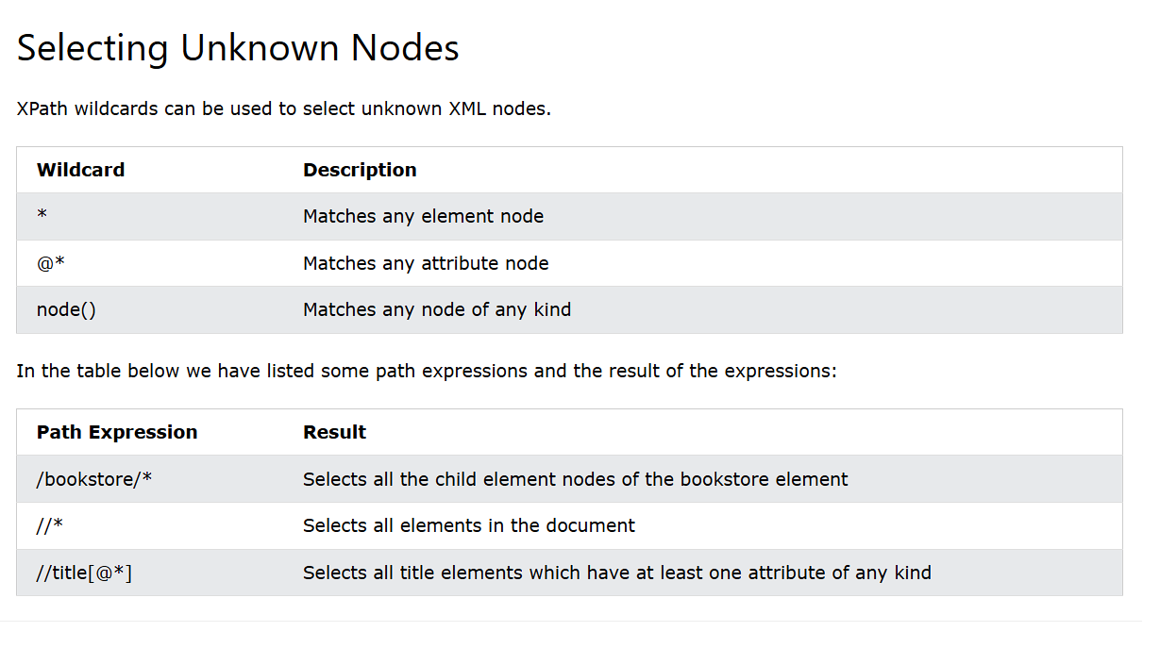

Using (*)

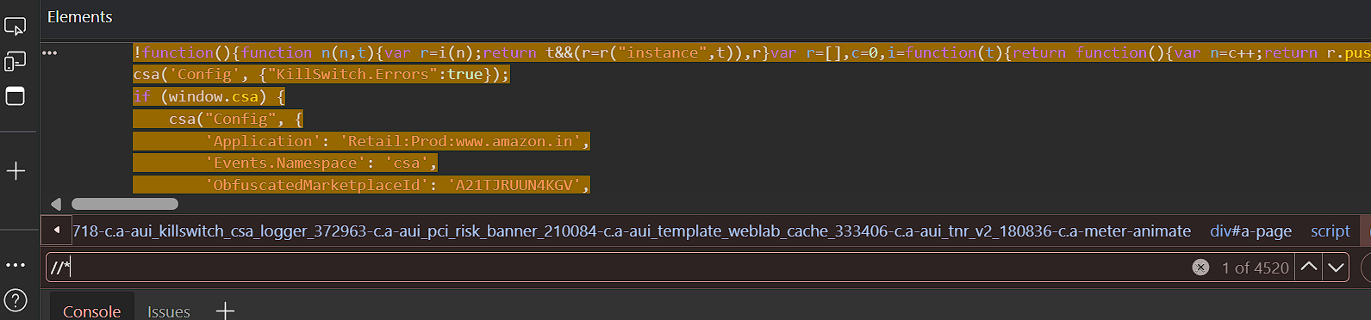

Using (@*)

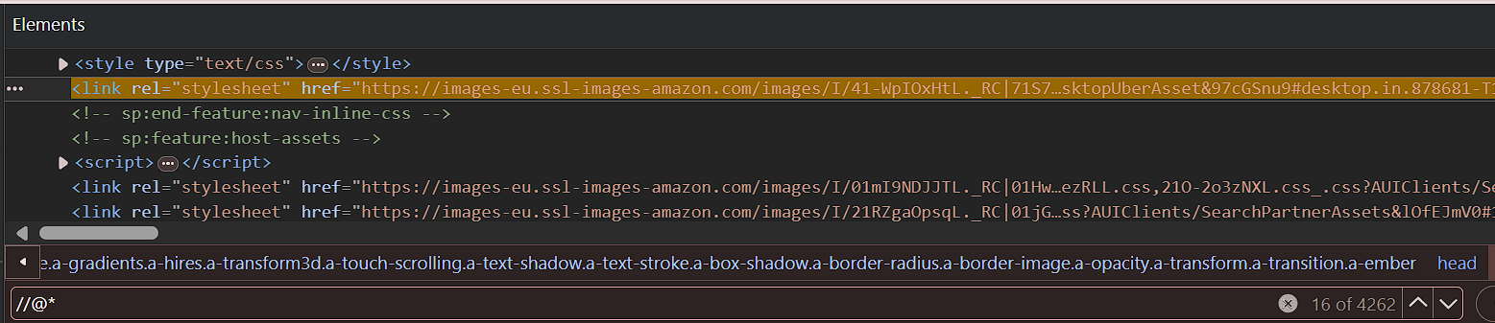

Using node()

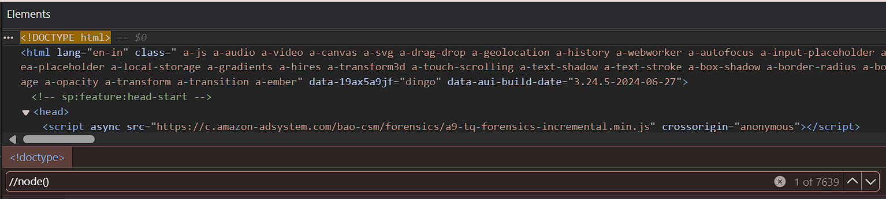

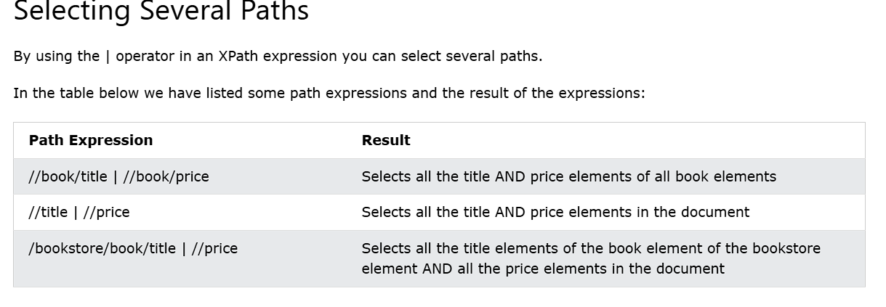

Using Logical AND in xpath,

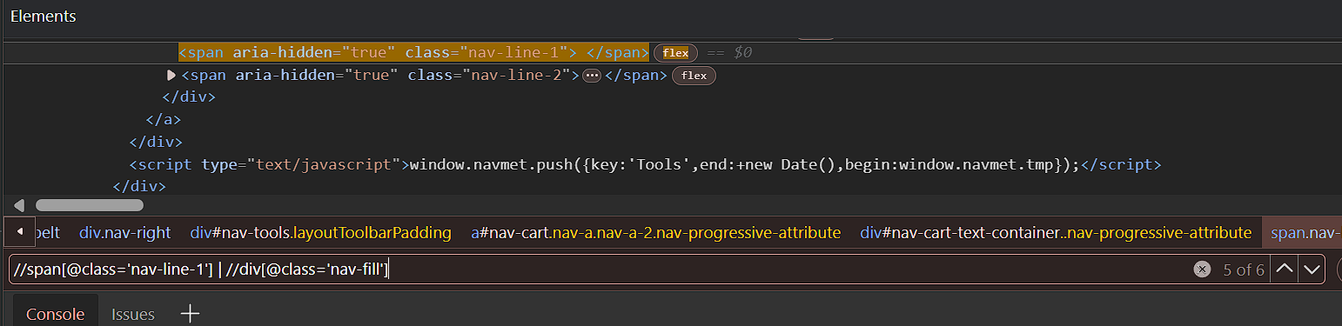

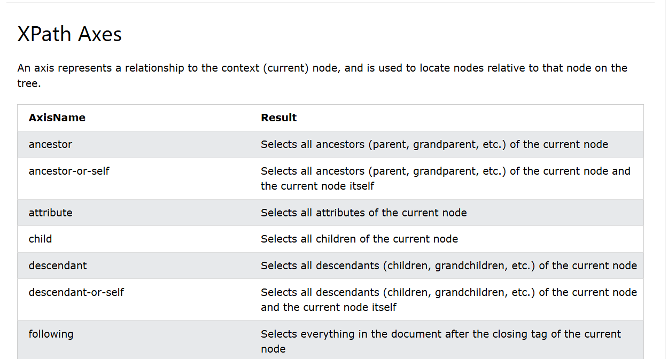

Using Ancestor

It fetches all the Ancestors matching the tag and it does not include the current node. If there are multiple ancestors with same kind of tag, the it can selected through index. The index count would in reverse order. The first index would be top most ancestor.

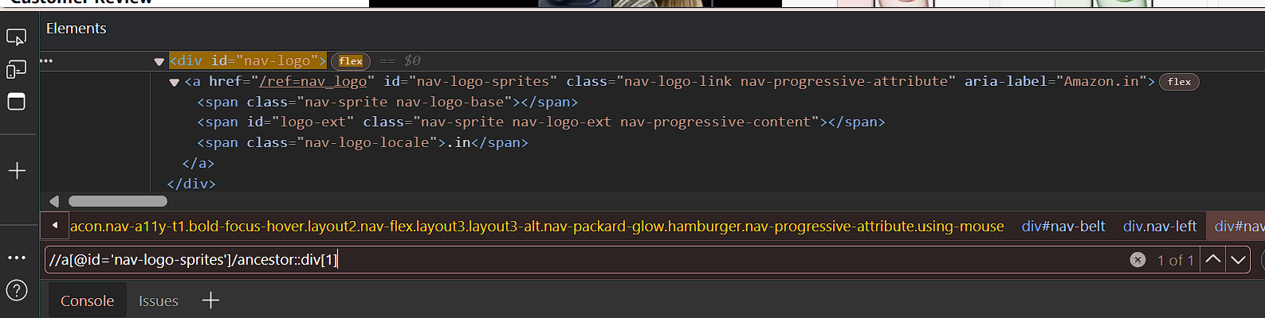

Using Ancestor or Self

It fetches all the Ancestors matching the tag and it includes the current node. If there are multiple ancestors with same kind of tag, the it can selected through index. The index count would in reverse order. The first index would be top most ancestor.

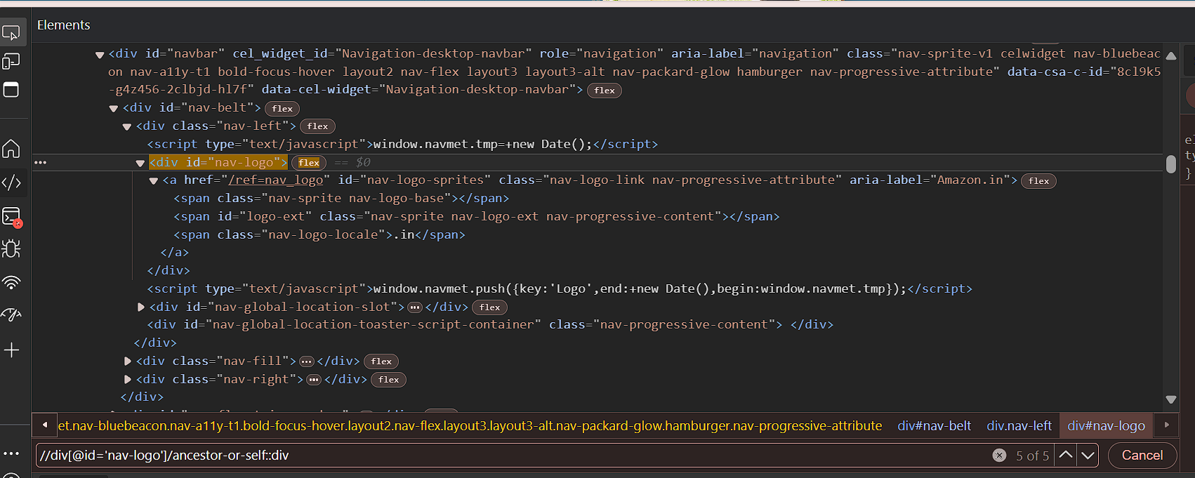

Using Child

Fetches all the child elements of the matching web element.

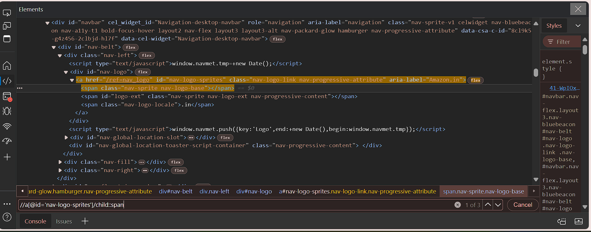

Descendent, descendant-or-self.

Descendant – will fetch all the childrens, grandchildren and does not includes the matching web element.

Descendant-or-self – will fetch all the childrens, grandchildrens and includes the matching web element as well.

For descendant,

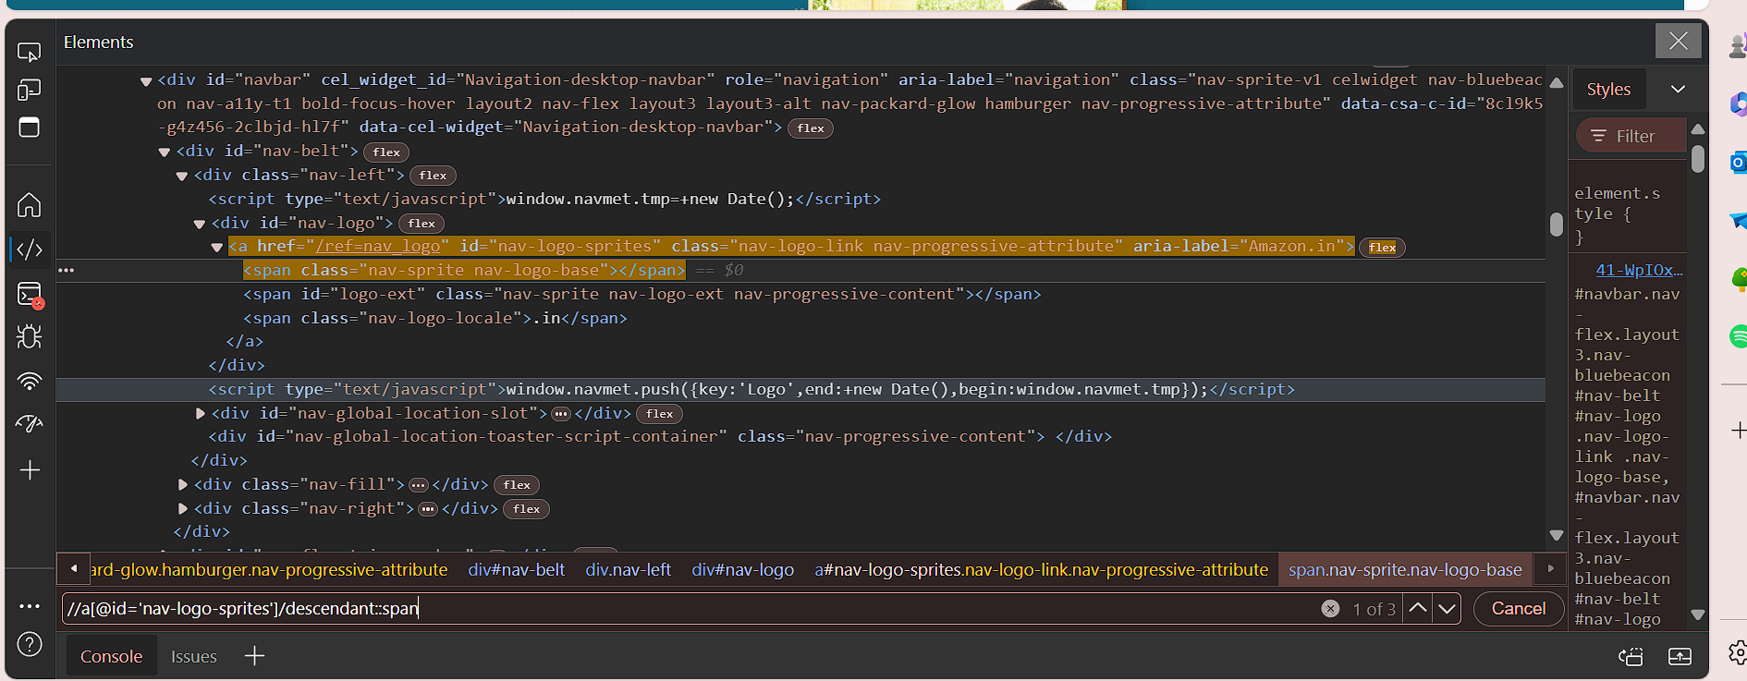

For Descendant-or-self,

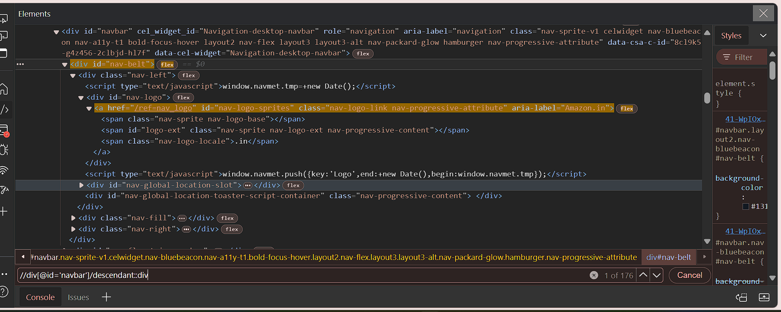

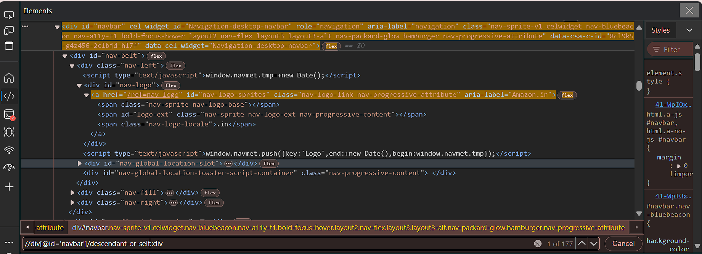

Using Following,

This fetches the siblings and their descendants of matching tag throughout the document, but not its descendants.

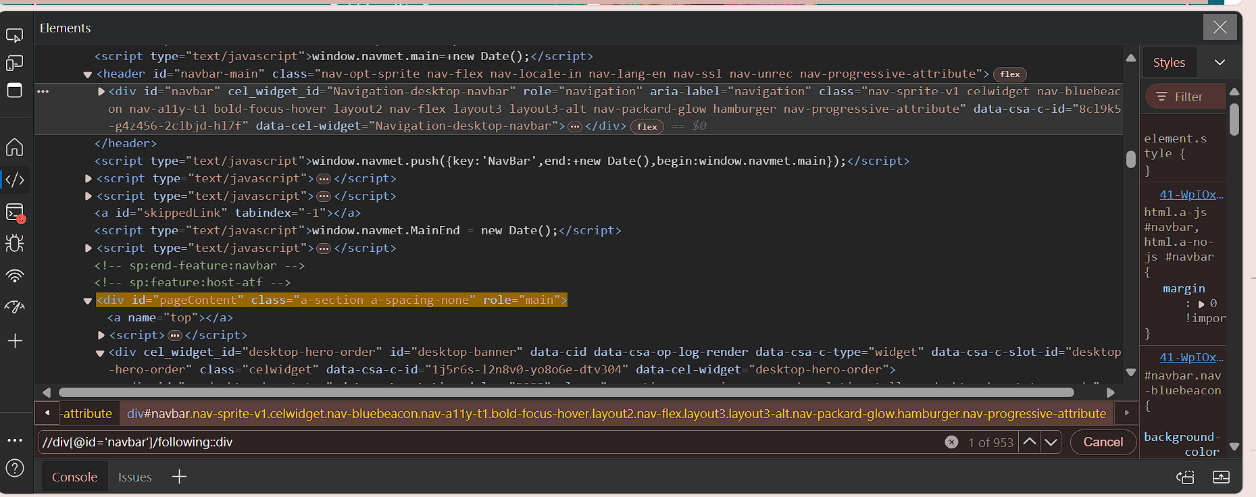

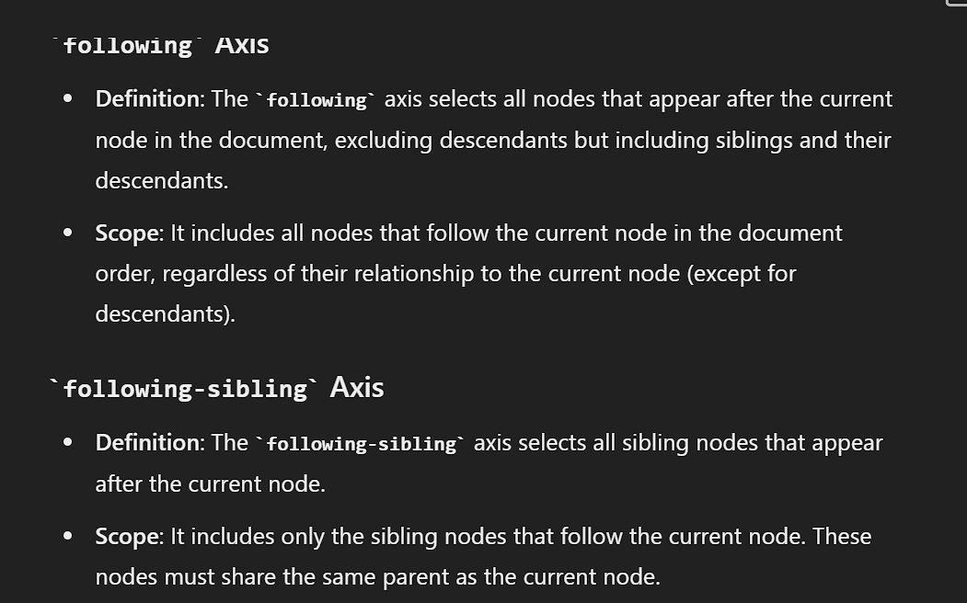

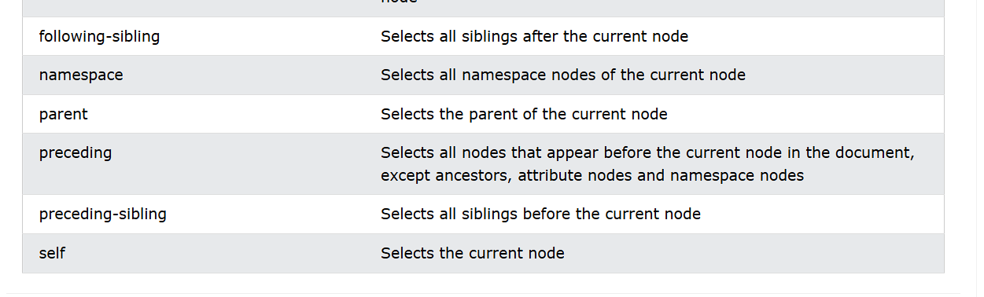

Using following-sibling

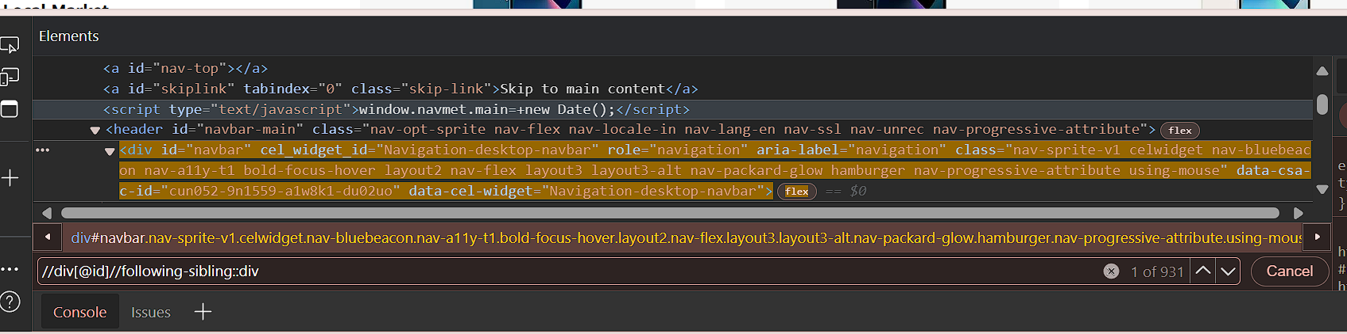

Using parent

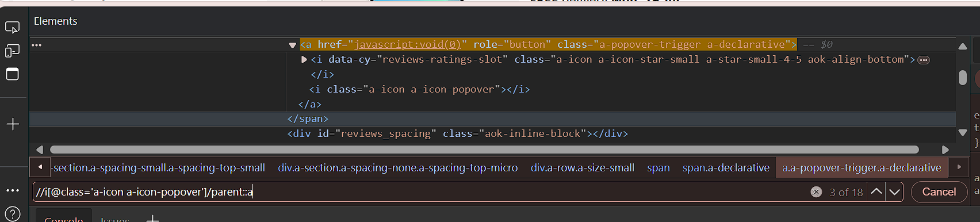

Using preceding,

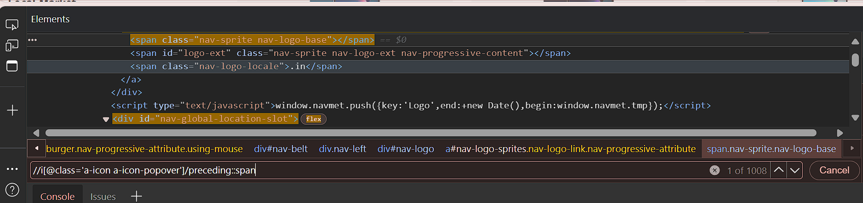

Using preceding-sibling,

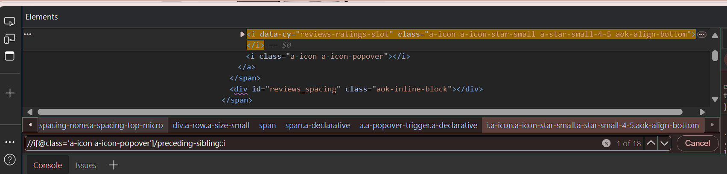

Using self

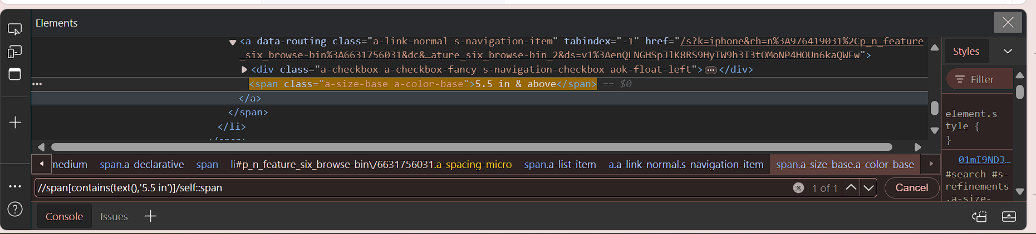

Handling Web Buttons in Selenium

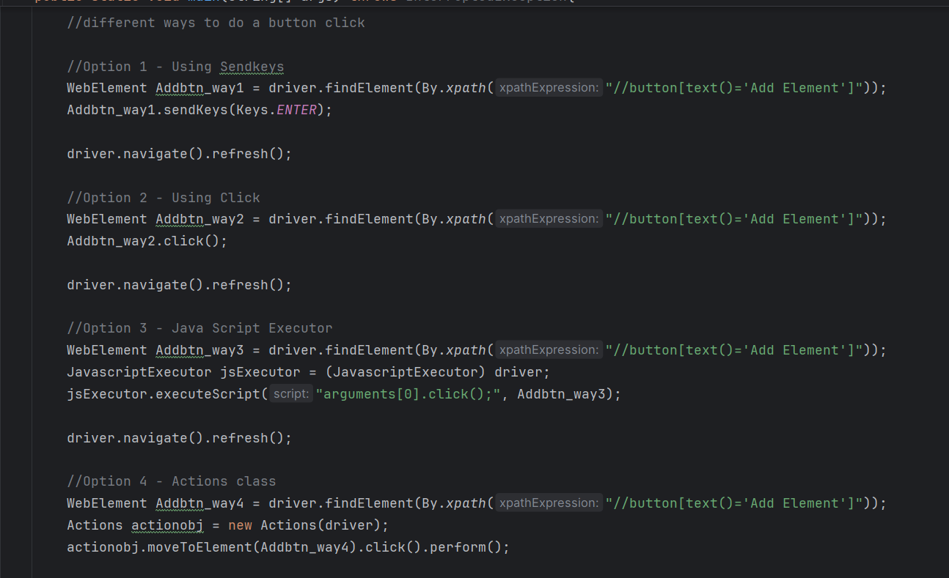

import org.openqa.selenium.*;

import org.openqa.selenium.edge.EdgeDriver;

import org.openqa.selenium.interactions.Actions;

import org.openqa.selenium.support.ui.Wait;

import java.time.Duration;

import java.util.Set;

import java.util.concurrent.TimeUnit;

public class Main {

public static void main(String[] args) throws InterruptedException{

// Set the Path to Edge Driver.exe

System.setProperty("webdriver.edge.driver",

"C:\\Users\\axfel\\SeleniumANDtestNG\\Drivers\\msedgedriver.exe");

// Initialize the Edge Driver

WebDriver driver = new EdgeDriver();

//.get() = Opens the specified URL in the Browser type Initialized.

driver.navigate().to("http://the-internet.herokuapp.com/add_remove_elements/");

//different ways to do a button click

//Option 1 - Using Sendkeys

WebElement Addbtn_way1 = driver.findElement(By.xpath("//button[text()='Add Element']"));

Addbtn_way1.sendKeys(Keys.ENTER);

driver.navigate().refresh();

//Option 2 - Using Click

WebElement Addbtn_way2 = driver.findElement(By.xpath("//button[text()='Add Element']"));

Addbtn_way2.click();

driver.navigate().refresh();

//Option 3 - Java Script Executor

WebElement Addbtn_way3 = driver.findElement(By.xpath("//button[text()='Add Element']"));

JavascriptExecutor jsExecutor = (JavascriptExecutor) driver;

jsExecutor.executeScript("arguments[0].click();", Addbtn_way3);

driver.navigate().refresh();

//Option 4 - Actions class

WebElement Addbtn_way4 = driver.findElement(By.xpath("//button[text()='Add Element']"));

Actions actionobj = new Actions(driver);

actionobj.moveToElement(Addbtn_way4).click().perform();

driver.quit();

}

}

Handling Inputs – Text Box

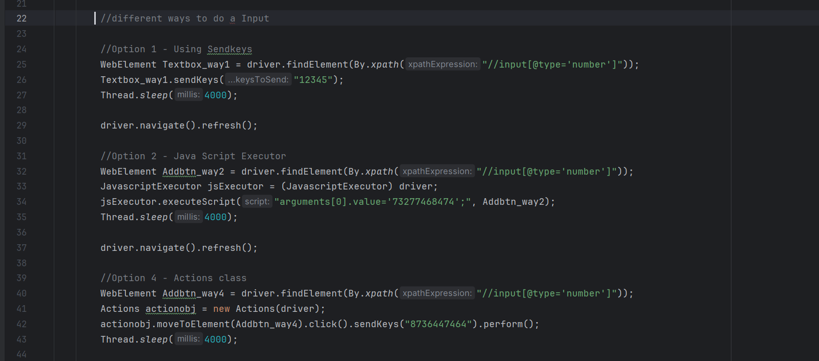

import org.openqa.selenium.*;

import org.openqa.selenium.edge.EdgeDriver;

import org.openqa.selenium.interactions.Actions;

import org.openqa.selenium.support.ui.Wait;

import java.time.Duration;

import java.util.Set;

import java.util.concurrent.TimeUnit;

public class Main {

public static void main(String[] args) throws InterruptedException{

// Set the Path to Edge Driver.exe

System.setProperty("webdriver.edge.driver",

"C:\\Users\\axfel\\SeleniumANDtestNG\\Drivers\\msedgedriver.exe");

// Initialize the Edge Driver

WebDriver driver = new EdgeDriver();

//.get() = Opens the specified URL in the Browser type Initialized.

driver.navigate().to("http://the-internet.herokuapp.com/inputs");

//different ways to do a Input

//Option 1 - Using Sendkeys

WebElement Textbox_way1 = driver.findElement(By.xpath("//input[@type='number']"));

Textbox_way1.sendKeys("12345");

Thread.sleep(4000);

driver.navigate().refresh();

//Option 2 - Java Script Executor

WebElement Addbtn_way2 = driver.findElement(By.xpath("//input[@type='number']"));

JavascriptExecutor jsExecutor = (JavascriptExecutor) driver;

jsExecutor.executeScript("arguments[0].value='73277468474';", Addbtn_way2);

Thread.sleep(4000);

driver.navigate().refresh();

//Option 4 - Actions class

WebElement Addbtn_way4 = driver.findElement(By.xpath("//input[@type='number']"));

Actions actionobj = new Actions(driver);

actionobj.moveToElement(Addbtn_way4).click().sendKeys("8736447464").perform();

Thread.sleep(4000);

driver.quit();

}

}

Handling Checkboxes,

For a checkbox, there is no separate inbuilt option to check or uncheck it. Click() is the method to check and uncheck it.

If the checkbox is already checked, then on executing element.click() it will unchecked.

If the checkbox is already unchecked, then on executing element.click() it will be checked.

After taking a object for checkbox, the DOM(means the web page) should not be refreshed. If it happens, then Stale element reference exception will be thrown if you execute an action in that element.

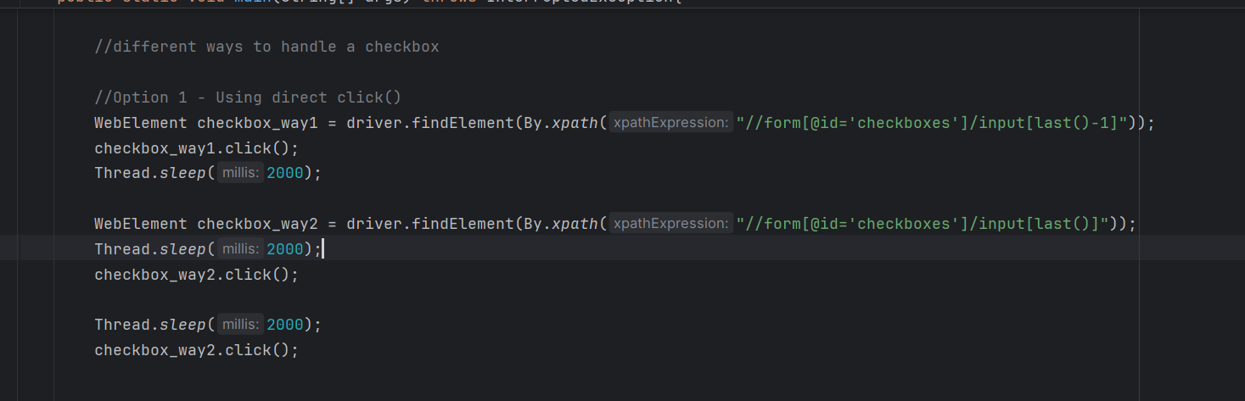

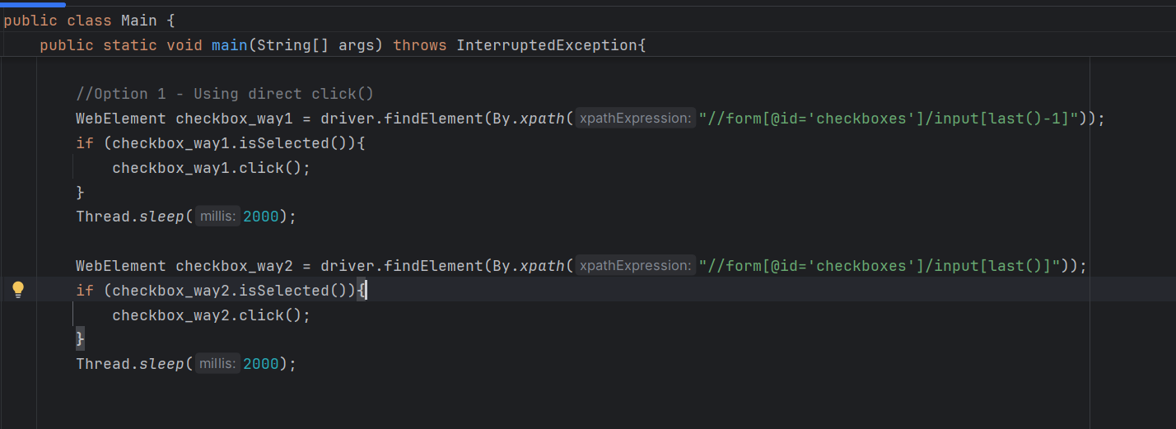

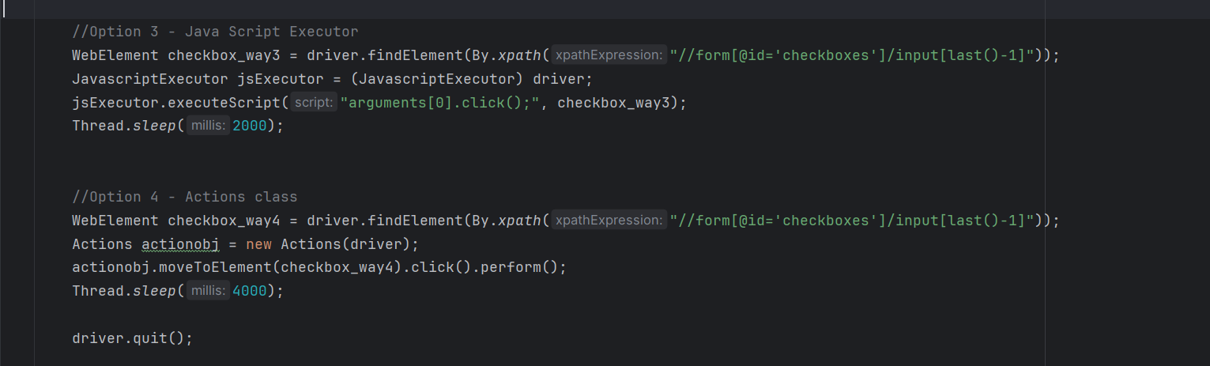

import org.openqa.selenium.*;  
import org.openqa.selenium.edge.EdgeDriver;  
import org.openqa.selenium.interactions.Actions;  
import org.openqa.selenium.support.ui.Wait;  
  
import java.time.Duration;  
import java.util.Set;  
import java.util.concurrent.TimeUnit;  
  
public class Main {  
 public static void main(String[] args) throws InterruptedException{  
 // Set the Path to Edge Driver.exe  
 System.*setProperty*("webdriver.edge.driver",  
 "C:\\Users\\axfel\\SeleniumANDtestNG\\Drivers\\msedgedriver.exe");  
  
 // Initialize the Edge Driver  
 WebDriver driver = new EdgeDriver();  
  
 //.get() = Opens the specified URL in the Browser type Initialized.  
 driver.navigate().to("https://the-internet.herokuapp.com/checkboxes");  
  
 //different ways to handle a checkbox  
  
 //Option 2 - Using click() with IsSelected()  
 WebElement checkbox_way1 = driver.findElement(By.*xpath*("//form[@id='checkboxes']/input[last()-1]"));  
 if (checkbox_way1.isSelected()){  
 checkbox_way1.click();  
 }  
 Thread.*sleep*(2000);  
  
 WebElement checkbox_way2 = driver.findElement(By.*xpath*("//form[@id='checkboxes']/input[last()]"));  
 if (checkbox_way2.isSelected()){  
 checkbox_way2.click();  
 }  
 Thread.*sleep*(2000);  
  
 //Option 3 - Java Script Executor  
 WebElement checkbox_way3 = driver.findElement(By.*xpath*("//form[@id='checkboxes']/input[last()-1]"));  
 JavascriptExecutor jsExecutor = (JavascriptExecutor) driver;  
 jsExecutor.executeScript("arguments[0].click();", checkbox_way3);  
 Thread.*sleep*(2000);  
  
  
 //Option 4 - Actions class  
 WebElement checkbox_way4 = driver.findElement(By.*xpath*("//form[@id='checkboxes']/input[last()-1]"));  
 Actions actionobj = new Actions(driver);  
 actionobj.moveToElement(checkbox_way4).click().perform();  
 Thread.*sleep*(4000);  
  
 driver.quit();  
  
 }  
}

Handling Radio Buttons

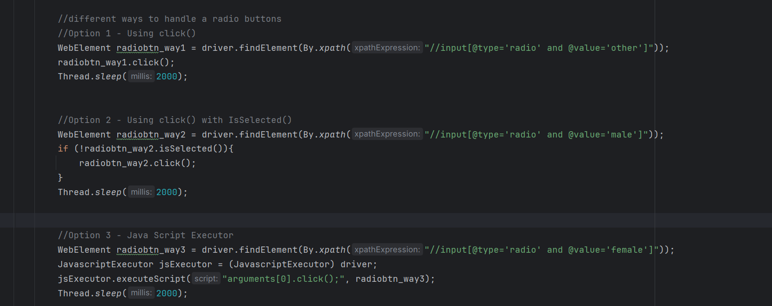

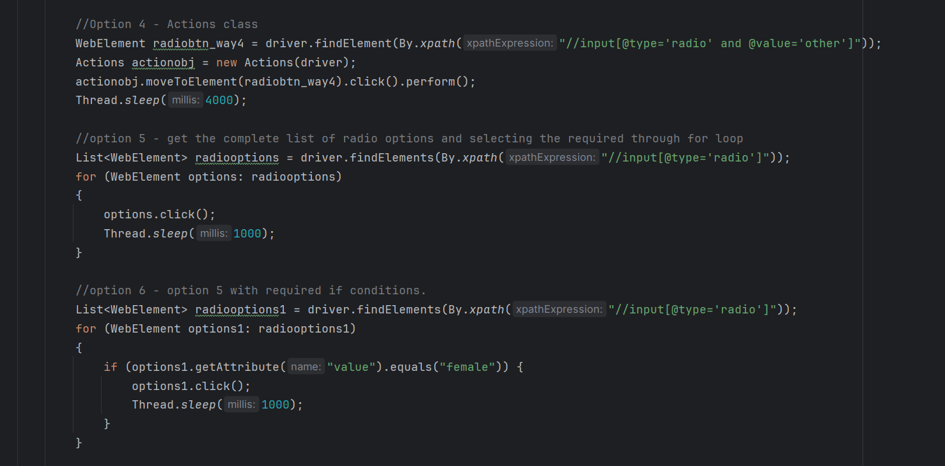

import org.openqa.selenium.*;  
import org.openqa.selenium.edge.EdgeDriver;  
import org.openqa.selenium.interactions.Actions;  
import org.openqa.selenium.support.ui.Wait;  
  
import java.time.Duration;  
import java.util.List;  
import java.util.Objects;  
import java.util.Set;  
import java.util.concurrent.TimeUnit;  
  
public class Main {  
 public static void main(String[] args) throws InterruptedException{  
 // Set the Path to Edge Driver.exe  
 System.*setProperty*("webdriver.edge.driver",  
 "C:\\Users\\axfel\\SeleniumANDtestNG\\Drivers\\msedgedriver.exe");  
  
 // Initialize the Edge Driver  
 WebDriver driver = new EdgeDriver();  
  
 //.get() = Opens the specified URL in the Browser type Initialized.  
 driver.navigate().to("https://ultimateqa.com/simple-html-elements-for-automation/");  
 driver.manage().window().maximize();  
  
 //different ways to handle a radio buttons  
 //Option 1 - Using click()  
 WebElement radiobtn_way1 = driver.findElement(By.*xpath*("//input[@type='radio' and @value='other']"));  
 radiobtn_way1.click();  
 Thread.*sleep*(2000);  
  
  
 //Option 2 - Using click() with IsSelected()  
 WebElement radiobtn_way2 = driver.findElement(By.*xpath*("//input[@type='radio' and @value='male']"));  
 if (!radiobtn_way2.isSelected()){  
 radiobtn_way2.click();  
 }  
 Thread.*sleep*(2000);  
  
  
 //Option 3 - Java Script Executor  
 WebElement radiobtn_way3 = driver.findElement(By.*xpath*("//input[@type='radio' and @value='female']"));  
 JavascriptExecutor jsExecutor = (JavascriptExecutor) driver;  
 jsExecutor.executeScript("arguments[0].click();", radiobtn_way3);  
 Thread.*sleep*(2000);  
  
 //Option 4 - Actions class  
 WebElement radiobtn_way4 = driver.findElement(By.*xpath*("//input[@type='radio' and @value='other']"));  
 Actions actionobj = new Actions(driver);  
 actionobj.moveToElement(radiobtn_way4).click().perform();  
 Thread.*sleep*(4000);  
  
 //option 5 - get the complete list of radio options and selecting the required through for loop  
 List<WebElement> radiooptions = driver.findElements(By.*xpath*("//input[@type='radio']"));  
 for (WebElement options: radiooptions)  
 {  
 options.click();  
 Thread.*sleep*(1000);  
 }  
  
 //option 6 - option 5 with required if conditions.  
 List<WebElement> radiooptions1 = driver.findElements(By.*xpath*("//input[@type='radio']"));  
 for (WebElement options1: radiooptions1)  
 {  
 if (options1.getAttribute("value").equals("female")) {  
 options1.click();  
 Thread.*sleep*(1000);  
 }  
 }  
  
 driver.quit();  
  
 }  
}

Handling Dropdowns

Using sendkeys() for selecting values from dropdown is good enough, but if focus is required, then we need to initiate a click on the dropdown and then use sendkeys() to select the option from dropdown.

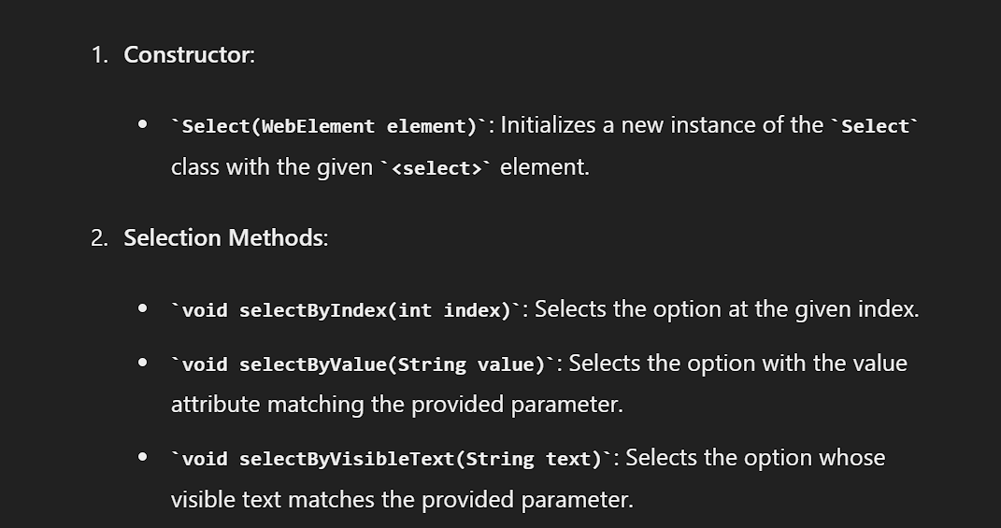

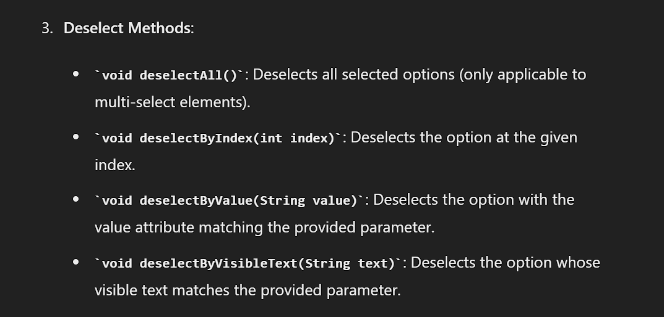

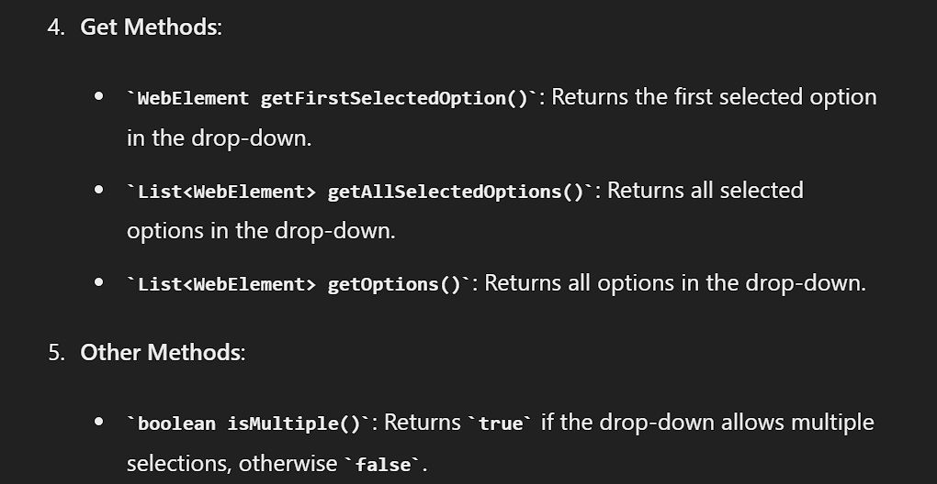

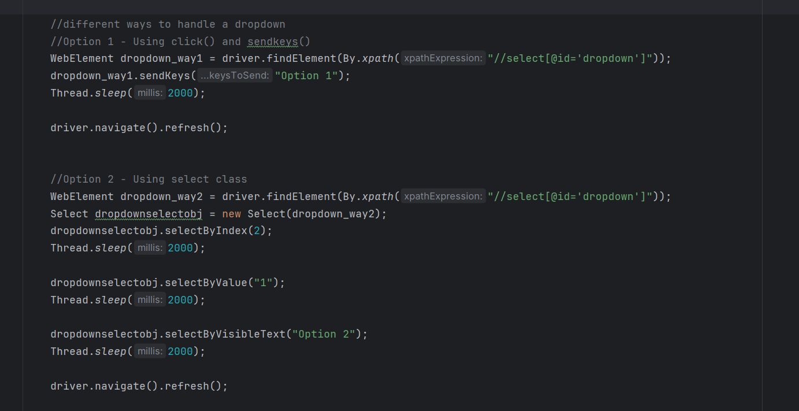

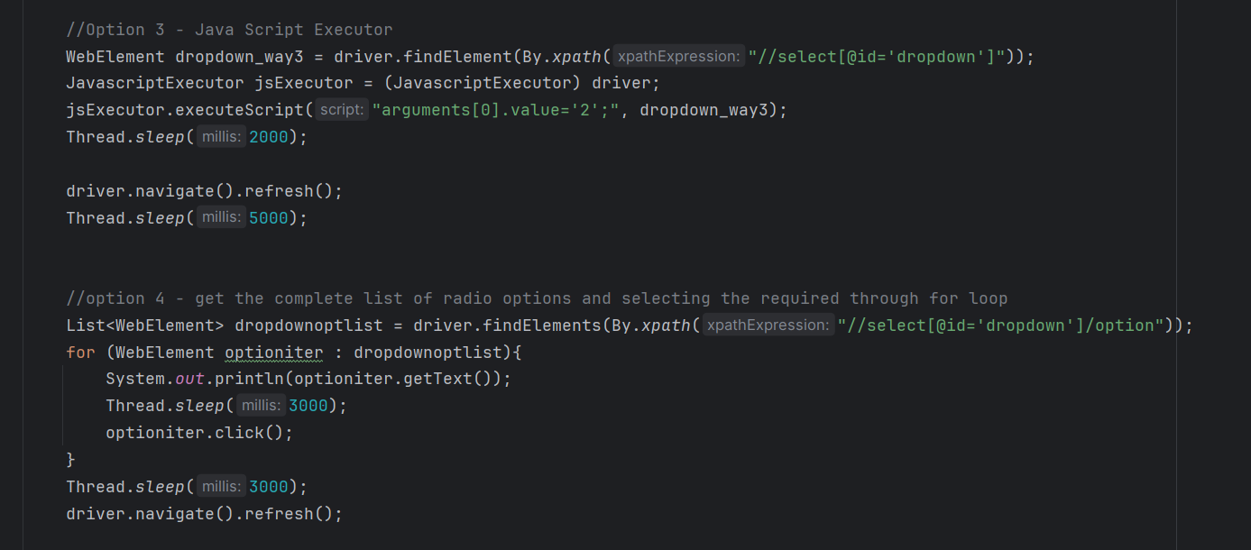

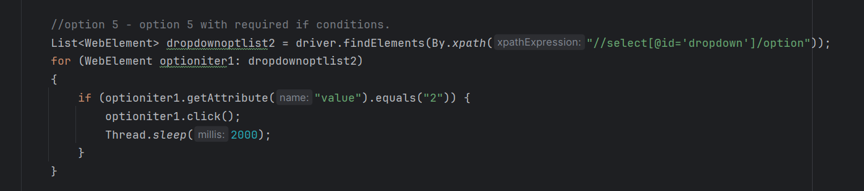

import org.openqa.selenium.*;  
import org.openqa.selenium.edge.EdgeDriver;  
import org.openqa.selenium.interactions.Actions;  
import org.openqa.selenium.support.ui.Select;  
import org.openqa.selenium.support.ui.Wait;  
  
import java.time.Duration;  
import java.util.List;  
import java.util.Objects;  
import java.util.Set;  
import java.util.concurrent.TimeUnit;  
  
public class Main {  
 public static void main(String[] args) throws InterruptedException{  
 // Set the Path to Edge Driver.exe  
 System.*setProperty*("webdriver.edge.driver",  
 "C:\\Users\\axfel\\SeleniumANDtestNG\\Drivers\\msedgedriver.exe");  
  
 // Initialize the Edge Driver  
 WebDriver driver = new EdgeDriver();  
  
 //.get() = Opens the specified URL in the Browser type Initialized.  
 driver.navigate().to("https://the-internet.herokuapp.com/dropdown");  
 driver.manage().window().maximize();  
  
 //different ways to handle a dropdown  
 //Option 1 - Using click() and sendkeys()  
 WebElement dropdown_way1 = driver.findElement(By.*xpath*("//select[@id='dropdown']"));  
 dropdown_way1.sendKeys("Option 1");  
 Thread.*sleep*(2000);  
  
 driver.navigate().refresh();  
  
  
 //Option 2 - Using select class  
 WebElement dropdown_way2 = driver.findElement(By.*xpath*("//select[@id='dropdown']"));  
 Select dropdownselectobj = new Select(dropdown_way2);  
 dropdownselectobj.selectByIndex(2);  
 Thread.*sleep*(2000);  
  
 dropdownselectobj.selectByValue("1");  
 Thread.*sleep*(2000);  
  
 dropdownselectobj.selectByVisibleText("Option 2");  
 Thread.*sleep*(2000);  
  
 driver.navigate().refresh();  
  
 //Option 3 - Java Script Executor  
 WebElement dropdown_way3 = driver.findElement(By.*xpath*("//select[@id='dropdown']"));  
 JavascriptExecutor jsExecutor = (JavascriptExecutor) driver;  
 jsExecutor.executeScript("arguments[0].value='2';", dropdown_way3);  
 Thread.*sleep*(2000);  
  
 driver.navigate().refresh();  
 Thread.*sleep*(5000);  
  
  
 //option 4 - get the complete list of radio options and selecting the required through for loop  
 List<WebElement> dropdownoptlist = driver.findElements(By.*xpath*("//select[@id='dropdown']/option"));  
 for (WebElement optioniter : dropdownoptlist){  
 System.*out*.println(optioniter.getText());  
 Thread.*sleep*(3000);  
 optioniter.click();  
 }  
 Thread.*sleep*(3000);  
 driver.navigate().refresh();  
  
 //option 5 - option 5 with required if conditions.  
 List<WebElement> dropdownoptlist2 = driver.findElements(By.*xpath*("//select[@id='dropdown']/option"));  
 for (WebElement optioniter1: dropdownoptlist2)  
 {  
 if (optioniter1.getAttribute("value").equals("2")) {  
 optioniter1.click();  
 Thread.*sleep*(2000);  
 }  
 }  
  
 driver.quit();  
  
 }  
}

Select() class inbuilt methods

Pre-requisite:-

Options of the dropdown should come directly under select tag, otherwise the select class and its methods cannot be used to automate it.

Constructor and Select methods are already available in the Dropdown handling code.

Rest of the methods are related to Multi select dropdowns which is not available at this moment, hence ignored it.

WebElement Inbuilt methods:

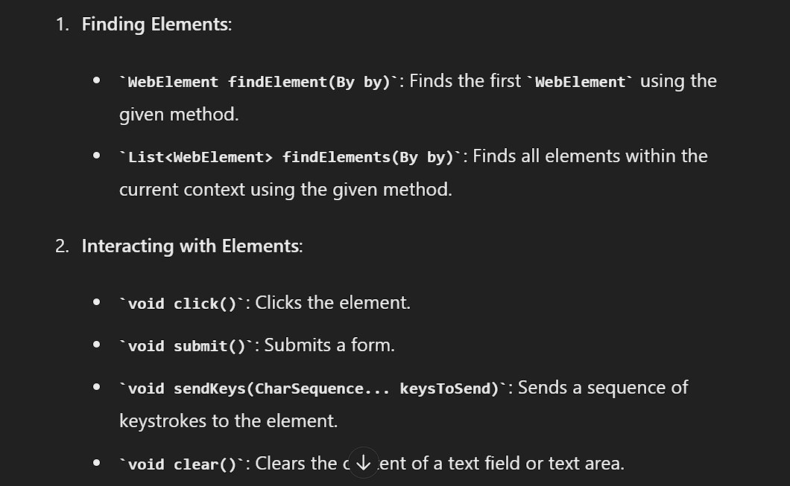

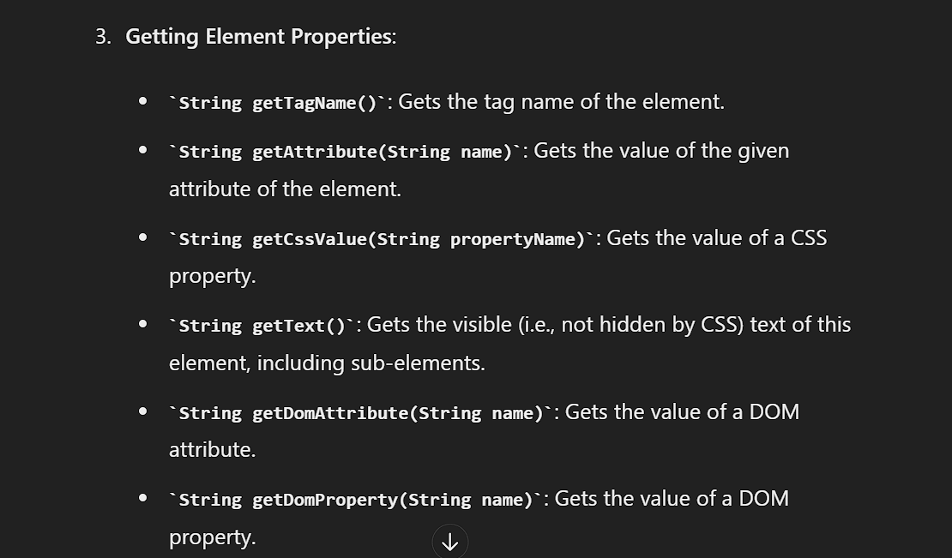

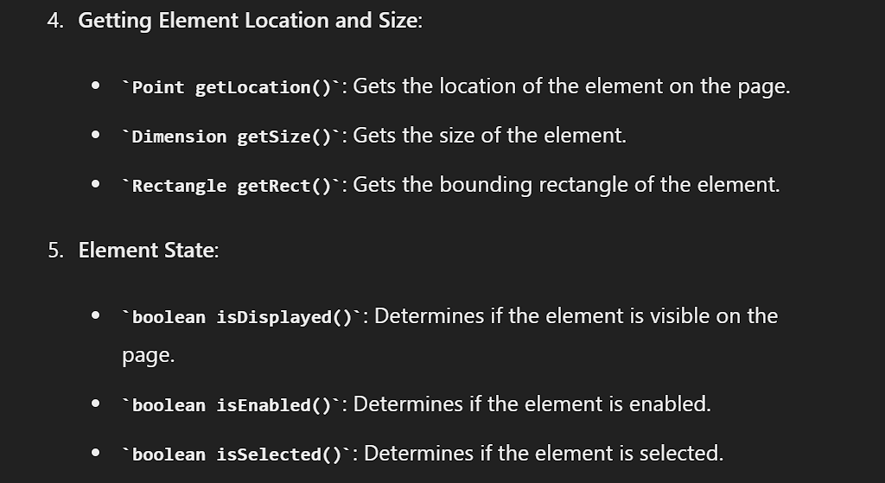

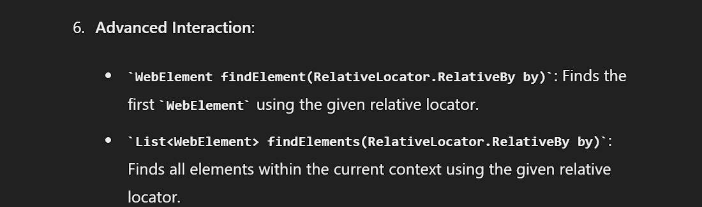

getaccessiblename()

The accessible name is typically derived from various attributes such as aria-label, title, alt, or the element's text content. This helps in making web applications more accessible by providing meaningful names for elements that can be read aloud by screen readers.

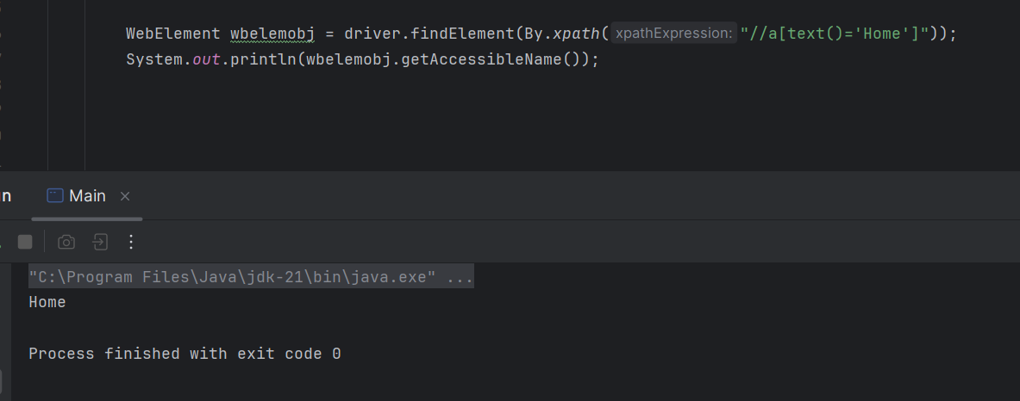

getAriarole()

The getAriaRole() method in the WebElement interface of Selenium WebDriver for Java retrieves the ARIA (Accessible Rich Internet Applications) role of a web element. ARIA roles are used to enhance the accessibility of web applications by providing additional semantic information about elements, which can be read by assistive technologies such as screen readers.

In short, it fetches the value of the role attribute.

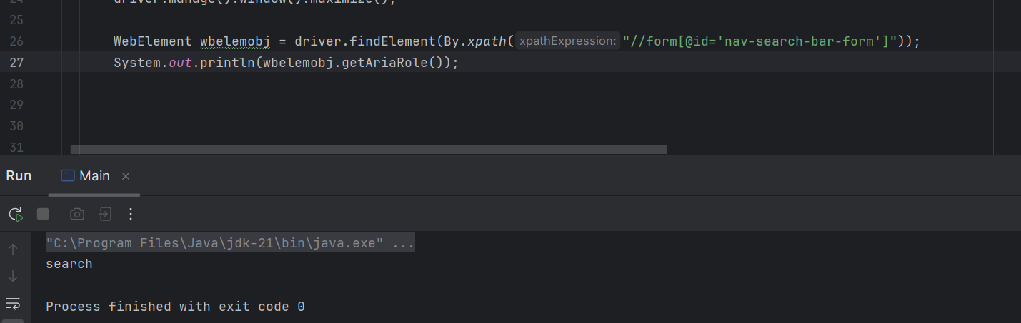

getshadowroot()

In Selenium WebDriver for Java, the getShadowRoot() method is used to access the Shadow DOM of a web element. The Shadow DOM is a part of the web component specification that allows for encapsulation of DOM and CSS, providing a way to keep the internal structure of a component hidden from the rest of the document.

The getShadowRoot() method allows Selenium to interact with elements inside a shadow tree.

**Accessing Shadow DOM**:

* First, locate the shadow host element.
* Use getShadowRoot() to retrieve the shadow root.
* Interact with elements inside the shadow root using regular WebDriver methods.

Action class and its methods

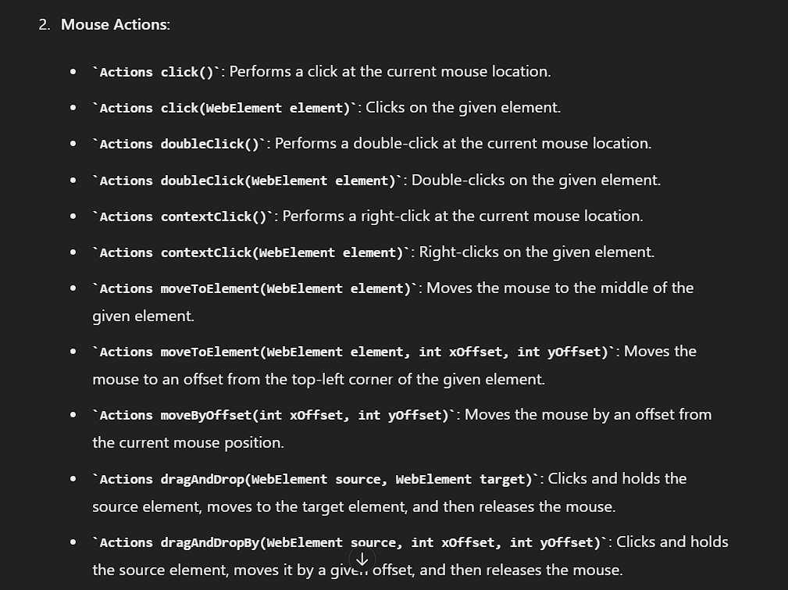

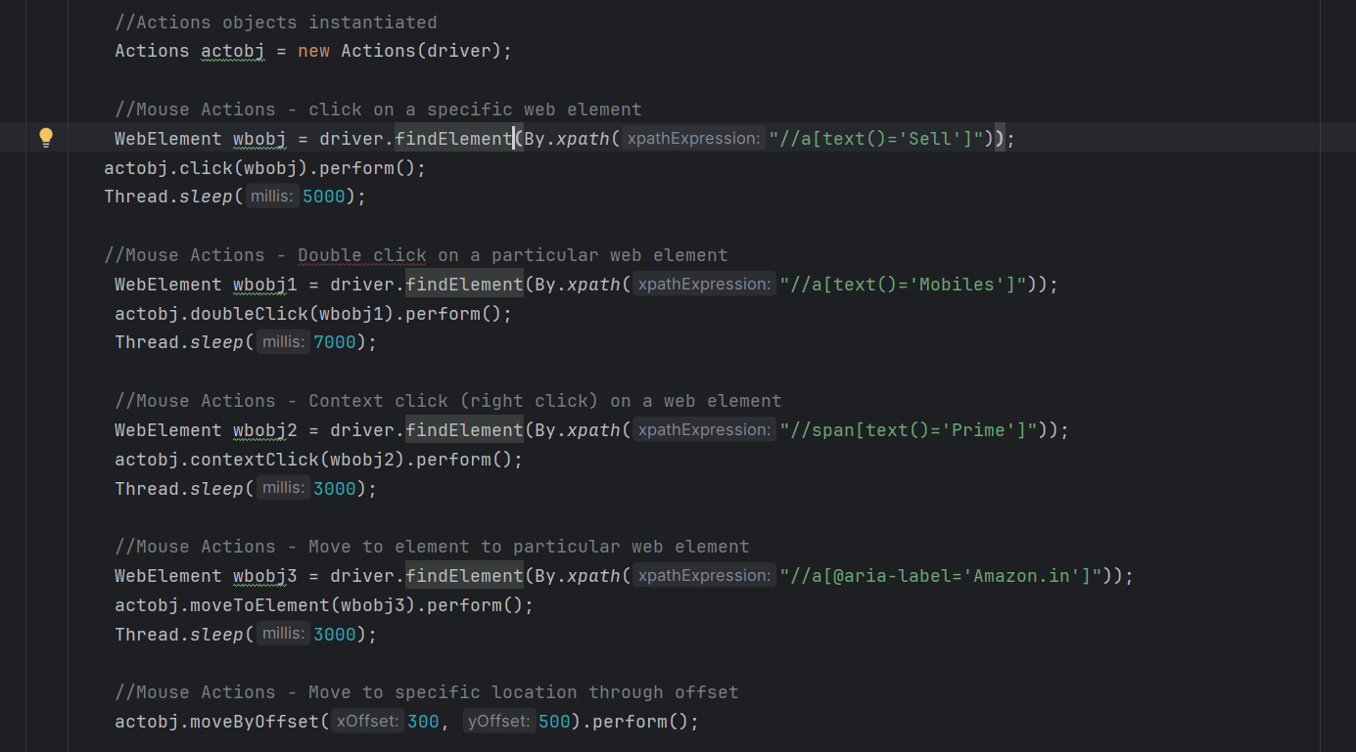

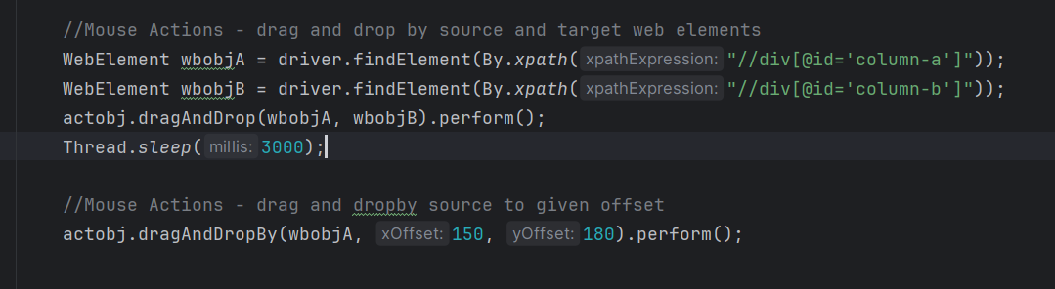

import org.openqa.selenium.*;  
import org.openqa.selenium.edge.EdgeDriver;  
import org.openqa.selenium.interactions.Actions;  
import org.openqa.selenium.support.ui.Select;  
import org.openqa.selenium.support.ui.Wait;  
  
import java.time.Duration;  
import java.util.List;  
import java.util.Objects;  
import java.util.Set;  
import java.util.concurrent.TimeUnit;  
  
public class Main {  
 public static void main(String[] args) throws InterruptedException{  
 // Set the Path to Edge Driver.exe  
 System.*setProperty*("webdriver.edge.driver",  
 "C:\\Users\\axfel\\SeleniumANDtestNG\\Drivers\\msedgedriver.exe");  
  
 // Initialize the Edge Driver  
 WebDriver driver = new EdgeDriver();  
  
 //.get() = Opens the specified URL in the Browser type Initialized.  
 driver.navigate().to("https://www.amazon.in/?tag=msndeskabkin-21&ref=pd_sl_6o3s351few_e&adgrpid=1317216540085412&hvadid=82326299628147&hvnetw=o&hvqmt=e&hvbmt=be&hvdev=c&hvlocint=90&hvlocphy=155055&hvtargid=kwd-82326918066337:loc-90&hydadcr=5621_2377279&msclkid=48c8d4bcc89b19b3d6d4b21e5d1d1c02");  
 driver.manage().window().maximize();  
  
 //Actions objects instantiated  
 Actions actobj = new Actions(driver);  
   
 //Mouse Actions - click on a specific web element  
 WebElement wbobj = driver.findElement(By.*xpath*("//a[text()='Sell']"));  
 actobj.click(wbobj).perform();  
 Thread.*sleep*(5000);  
  
 //Mouse Actions - Double click on a particular web element  
 WebElement wbobj1 = driver.findElement(By.*xpath*("//a[text()='Mobiles']"));  
 actobj.doubleClick(wbobj1).perform();  
 Thread.*sleep*(7000);  
  
 //Mouse Actions - Context click (right click) on a web element  
 WebElement wbobj2 = driver.findElement(By.*xpath*("//span[text()='Prime']"));  
 actobj.contextClick(wbobj2).perform();  
 Thread.*sleep*(3000);  
  
 //Mouse Actions - Move to element to particular web element  
 WebElement wbobj3 = driver.findElement(By.*xpath*("//a[@aria-label='Amazon.in']"));  
 actobj.moveToElement(wbobj3).perform();  
 Thread.*sleep*(3000);  
  
 //Mouse Actions - Move to specific location through offset  
 actobj.moveByOffset(300, 500).perform();  
  
  
  
  
  
  
  
 Thread.*sleep*(5000);  
 driver.quit();  
  
 }  
}

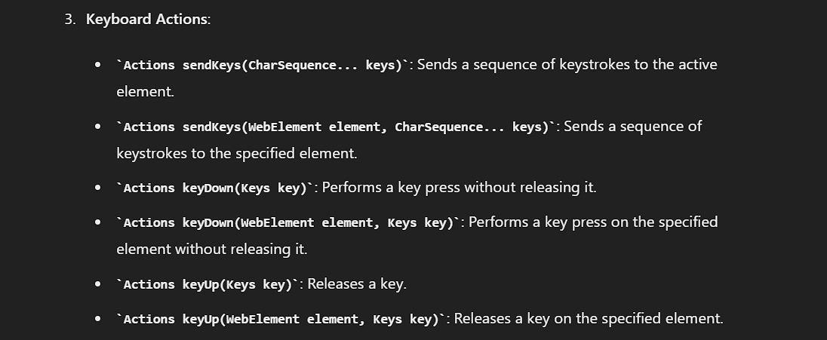

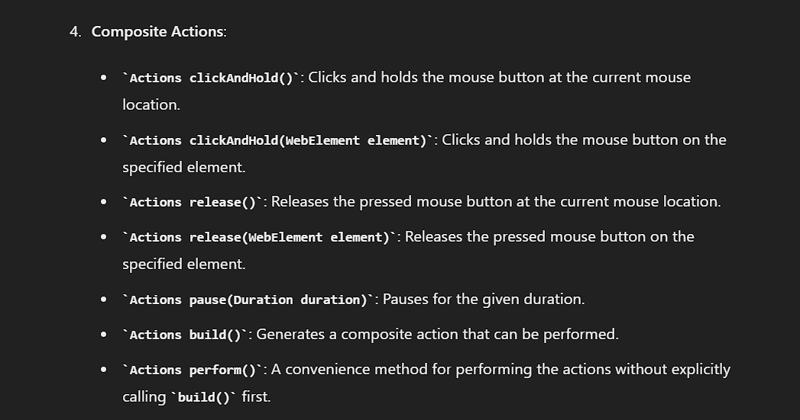

How to Handle alerts

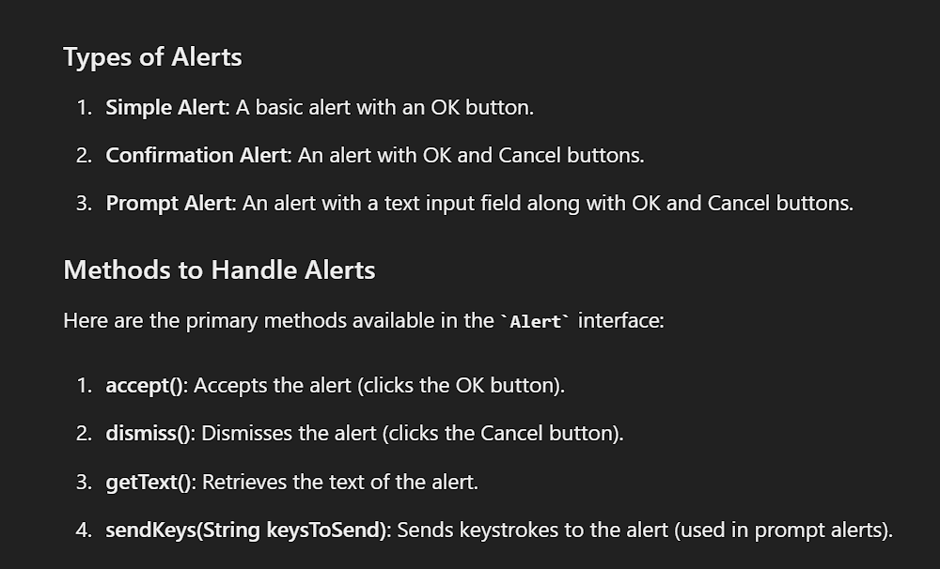

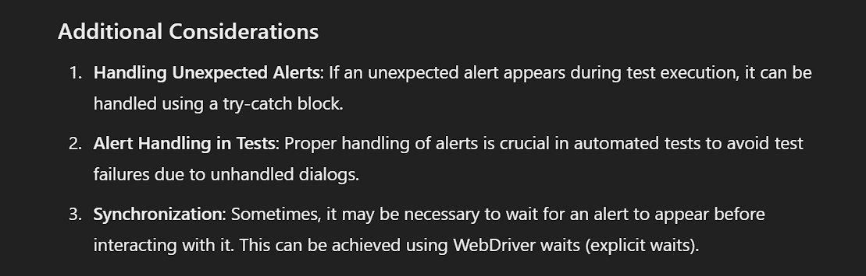

Simple Alert

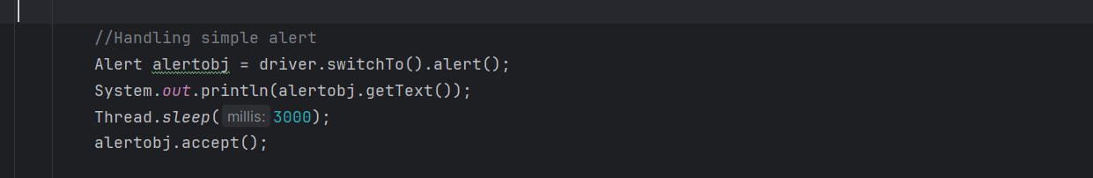

import org.openqa.selenium.*;  
import org.openqa.selenium.edge.EdgeDriver;  
import org.openqa.selenium.interactions.Actions;  
import org.openqa.selenium.support.ui.Select;  
import org.openqa.selenium.support.ui.Wait;  
  
import java.time.Duration;  
import java.util.List;  
import java.util.Objects;  
import java.util.Set;  
import java.util.concurrent.TimeUnit;  
  
public class Main {  
 public static void main(String[] args) throws InterruptedException{  
 // Set the Path to Edge Driver.exe  
 System.*setProperty*("webdriver.edge.driver",  
 "C:\\Users\\axfel\\SeleniumANDtestNG\\Drivers\\msedgedriver.exe");  
  
 // Initialize the Edge Driver  
 WebDriver driver = new EdgeDriver();  
  
 //.get() = Opens the specified URL in the Browser type Initialized.  
 driver.navigate().to("https://demoqa.com/alerts");  
 Thread.*sleep*(6000);  
 driver.manage().window().maximize();  
 Actions actobj = new Actions(driver);  
  
 //Pre-requisite  
 actobj.sendKeys(Keys.*PAGE_DOWN*).perform();  
 WebElement wbobj = driver.findElement(By.*xpath*("//button[@id='alertButton']"));  
 wbobj.click();  
  
 //Handling simple alert  
 Alert alertobj = driver.switchTo().alert();  
 System.*out*.println(alertobj.getText());  
 Thread.*sleep*(3000);  
 alertobj.accept();  
  
  
 Thread.*sleep*(6000);  
 driver.quit();  
  
 }  
}

Confirmation Alert

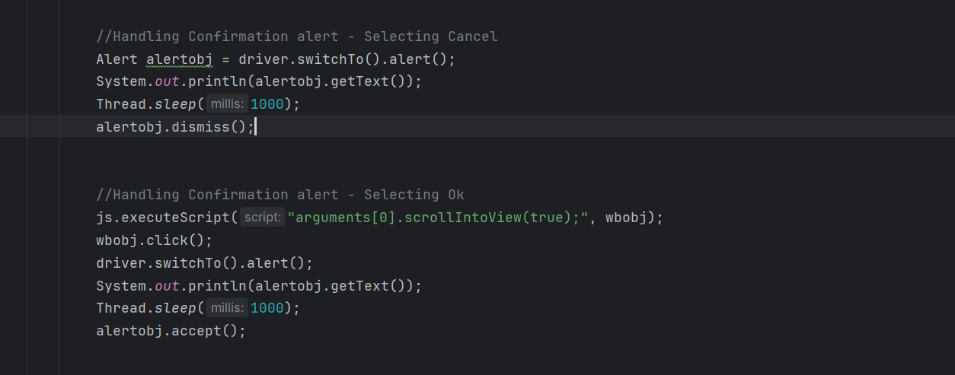

import org.openqa.selenium.*;  
import org.openqa.selenium.edge.EdgeDriver;  
import org.openqa.selenium.interactions.Actions;  
import org.openqa.selenium.support.ui.Select;  
import org.openqa.selenium.support.ui.Wait;  
  
import java.time.Duration;  
import java.util.List;  
import java.util.Objects;  
import java.util.Set;  
import java.util.concurrent.TimeUnit;  
  
public class Main {  
 public static void main(String[] args) throws InterruptedException{  
 // Set the Path to Edge Driver.exe  
 System.*setProperty*("webdriver.edge.driver",  
 "C:\\Users\\axfel\\SeleniumANDtestNG\\Drivers\\msedgedriver.exe");  
  
 // Initialize the Drivers  
 WebDriver driver = new EdgeDriver();  
 Actions actobj = new Actions(driver);  
 JavascriptExecutor js = (JavascriptExecutor) driver;  
  
 //.get() = Opens the specified URL in the Browser type Initialized.  
 driver.get("https://demoqa.com/alerts");  
 Thread.*sleep*(5000);  
 driver.manage().window().maximize();  
  
 //Pre-requisite  
 WebElement wbobj = driver.findElement(By.*xpath*("//button[@id='confirmButton']"));  
 js.executeScript("arguments[0].scrollIntoView(true);", wbobj);  
 wbobj.click();  
 Thread.*sleep*(2000);  
  
  
 //Handling Confirmation alert - Selecting Cancel  
 Alert alertobj = driver.switchTo().alert();  
 System.*out*.println(alertobj.getText());  
 Thread.*sleep*(1000);  
 alertobj.dismiss();  
  
  
 //Handling Confirmation alert - Selecting Ok  
 js.executeScript("arguments[0].scrollIntoView(true);", wbobj);  
 wbobj.click();  
 driver.switchTo().alert();  
 System.*out*.println(alertobj.getText());  
 Thread.*sleep*(1000);  
 alertobj.accept();  
  
  
 Thread.*sleep*(3000);  
 driver.quit();  
  
 }  
}

Prompt Alert

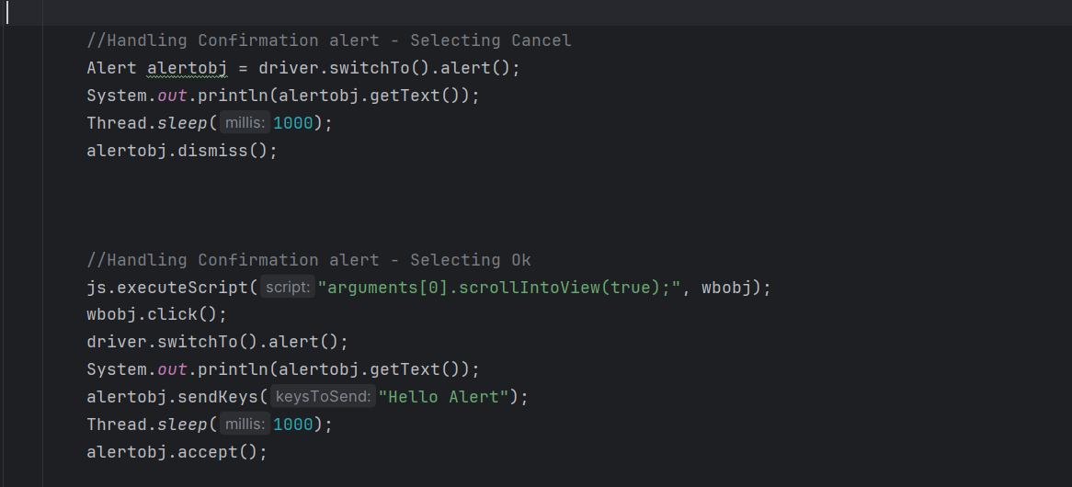

import org.openqa.selenium.*;  
import org.openqa.selenium.edge.EdgeDriver;  
import org.openqa.selenium.interactions.Actions;  
import org.openqa.selenium.support.ui.Select;  
import org.openqa.selenium.support.ui.Wait;  
  
import java.time.Duration;  
import java.util.List;  
import java.util.Objects;  
import java.util.Set;  
import java.util.concurrent.TimeUnit;  
  
public class Main {  
 public static void main(String[] args) throws InterruptedException{  
 // Set the Path to Edge Driver.exe  
 System.*setProperty*("webdriver.edge.driver",  
 "C:\\Users\\axfel\\SeleniumANDtestNG\\Drivers\\msedgedriver.exe");  
  
 // Initialize the Drivers  
 WebDriver driver = new EdgeDriver();  
 Actions actobj = new Actions(driver);  
 JavascriptExecutor js = (JavascriptExecutor) driver;  
  
 //.get() = Opens the specified URL in the Browser type Initialized.  
 driver.get("https://demoqa.com/alerts");  
 Thread.*sleep*(5000);  
 driver.manage().window().maximize();  
  
 //Pre-requisite  
 WebElement wbobj = driver.findElement(By.*xpath*("//button[@id='promtButton']"));  
 js.executeScript("arguments[0].scrollIntoView(true);", wbobj);  
 wbobj.click();  
 Thread.*sleep*(2000);  
  
  
 //Handling Confirmation alert - Selecting Cancel  
 Alert alertobj = driver.switchTo().alert();  
 System.*out*.println(alertobj.getText());  
 Thread.*sleep*(1000);  
 alertobj.dismiss();  
  
  
  
 //Handling Confirmation alert - Selecting Ok  
 js.executeScript("arguments[0].scrollIntoView(true);", wbobj);  
 wbobj.click();  
 driver.switchTo().alert();  
 System.*out*.println(alertobj.getText());  
 alertobj.sendKeys("Hello Alert");  
 Thread.*sleep*(1000);  
 alertobj.accept();  
  
  
 Thread.*sleep*(3000);  
 driver.quit();  
  
 }  
}

Handling Frames

There are different methods to identify a frame based on the available attributes.

1. Switch to frame by index
2. Switch to Frame by name or ID
3. Switch to frame by Web element
4. Switch to Parent frame
5. Switch to Default content
6. Switch to nested frames

Option 4, 6.

Switching to Nested frames is same as switching between two different frames. In the perspective of nested frames, just switch to Outer frame and then keep on switching to Inner frame until you reach the target one.

Within the nested frames, if you want to get back to previous frames we have to use switch to parent frame.

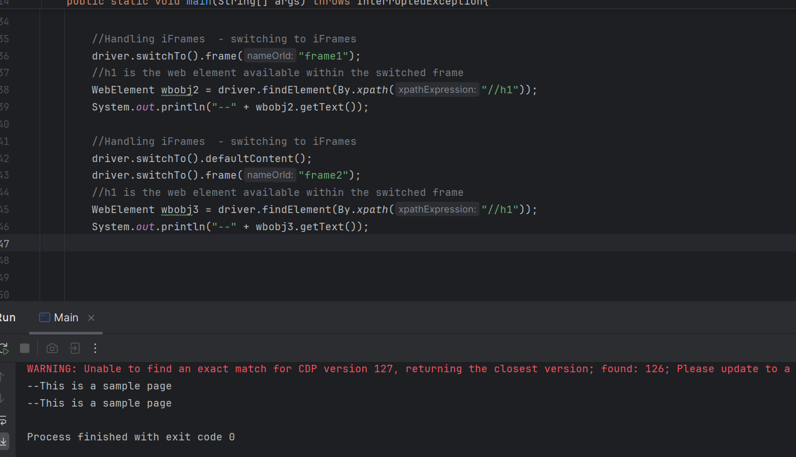

import org.openqa.selenium.*;  
import org.openqa.selenium.edge.EdgeDriver;  
import org.openqa.selenium.interactions.Actions;  
import org.openqa.selenium.support.ui.Select;  
import org.openqa.selenium.support.ui.Wait;  
  
import java.time.Duration;  
import java.util.List;  
import java.util.Objects;  
import java.util.Set;  
import java.util.concurrent.TimeUnit;  
  
public class Main {  
 public static void main(String[] args) throws InterruptedException{  
 // Set the Path to Edge Driver.exe  
 System.*setProperty*("webdriver.edge.driver",  
 "C:\\Users\\axfel\\SeleniumANDtestNG\\Drivers\\msedgedriver.exe");  
  
 // Initialize the Drivers  
 WebDriver driver = new EdgeDriver();  
 Actions actobj = new Actions(driver);  
 JavascriptExecutor js = (JavascriptExecutor) driver;  
  
 //.get() = Opens the specified URL in the Browser type Initialized.  
 driver.get("https://demoqa.com/frames");  
 Thread.*sleep*(3000);  
 driver.manage().window().maximize();  
  
 //Pre-requisite  
 WebElement wbobj = driver.findElement(By.*xpath*("//iframe[@id='frame1']"));  
 js.executeScript("arguments[0].scrollIntoView(true);", wbobj);  
 //Thread.sleep(2000);  
  
  
 //Handling iFrames - switching to iFrames  
 driver.switchTo().frame("frame1");  
 //h1 is the web element available within the switched frame  
 WebElement wbobj2 = driver.findElement(By.*xpath*("//h1"));  
 System.*out*.println("--" + wbobj2.getText());  
  
 //Handling iFrames - switching to iFrames  
 driver.switchTo().defaultContent();  
 driver.switchTo().frame("frame2");  
 //h1 is the web element available within the switched frame  
 WebElement wbobj3 = driver.findElement(By.*xpath*("//h1"));  
 System.*out*.println("--" + wbobj3.getText());  
  
  
 Thread.*sleep*(3000);  
 driver.quit();  
  
 }  
}

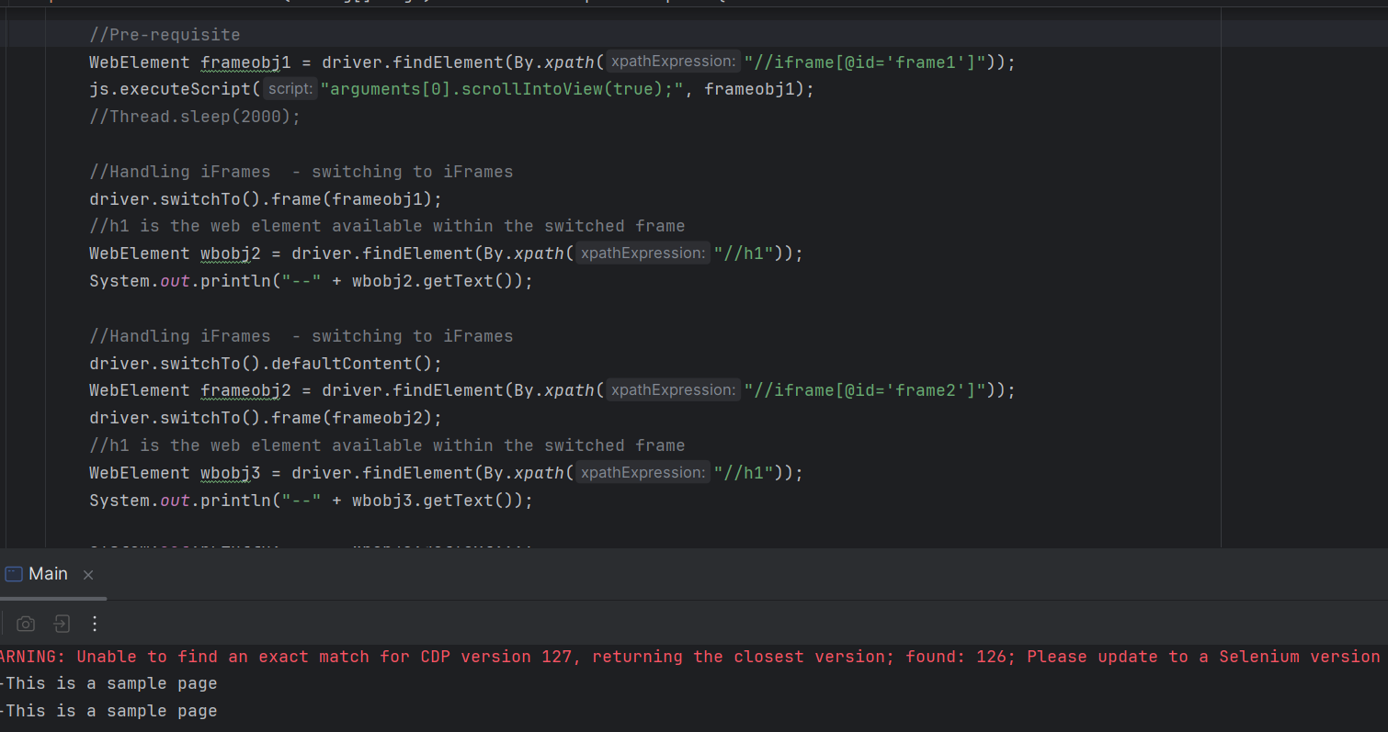

import org.openqa.selenium.*;  
import org.openqa.selenium.edge.EdgeDriver;  
import org.openqa.selenium.interactions.Actions;  
import org.openqa.selenium.support.ui.Select;  
import org.openqa.selenium.support.ui.Wait;  
  
import java.time.Duration;  
import java.util.List;  
import java.util.Objects;  
import java.util.Set;  
import java.util.concurrent.TimeUnit;  
  
public class Main {  
 public static void main(String[] args) throws InterruptedException{  
 // Set the Path to Edge Driver.exe  
 System.*setProperty*("webdriver.edge.driver",  
 "C:\\Users\\axfel\\SeleniumANDtestNG\\Drivers\\msedgedriver.exe");  
  
 // Initialize the Drivers  
 WebDriver driver = new EdgeDriver();  
 Actions actobj = new Actions(driver);  
 JavascriptExecutor js = (JavascriptExecutor) driver;  
  
 //.get() = Opens the specified URL in the Browser type Initialized.  
 driver.get("https://demoqa.com/frames");  
 Thread.*sleep*(3000);  
 driver.manage().window().maximize();  
  
 //Pre-requisite  
 WebElement frameobj1 = driver.findElement(By.*xpath*("//iframe[@id='frame1']"));  
 js.executeScript("arguments[0].scrollIntoView(true);", frameobj1);  
 //Thread.sleep(2000);  
  
 //Handling iFrames - switching to iFrames  
 driver.switchTo().frame(frameobj1);  
 //h1 is the web element available within the switched frame  
 WebElement wbobj2 = driver.findElement(By.*xpath*("//h1"));  
 System.*out*.println("--" + wbobj2.getText());  
  
 //Handling iFrames - switching to iFrames  
 driver.switchTo().defaultContent();  
 WebElement frameobj2 = driver.findElement(By.*xpath*("//iframe[@id='frame2']"));  
 driver.switchTo().frame(frameobj2);  
 //h1 is the web element available within the switched frame  
 WebElement wbobj3 = driver.findElement(By.*xpath*("//h1"));  
 System.*out*.println("--" + wbobj3.getText());  
  
  
 Thread.*sleep*(3000);  
 driver.quit();  
  
 }  
}

Nested Frames

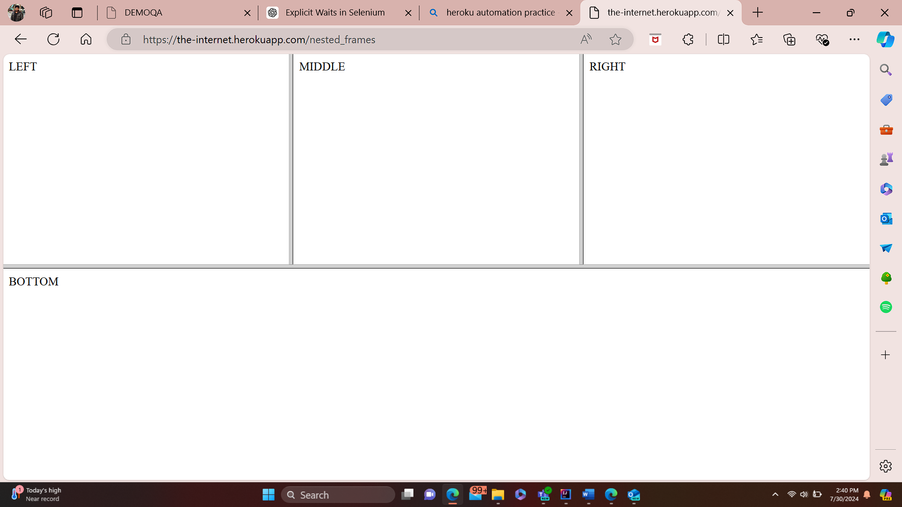

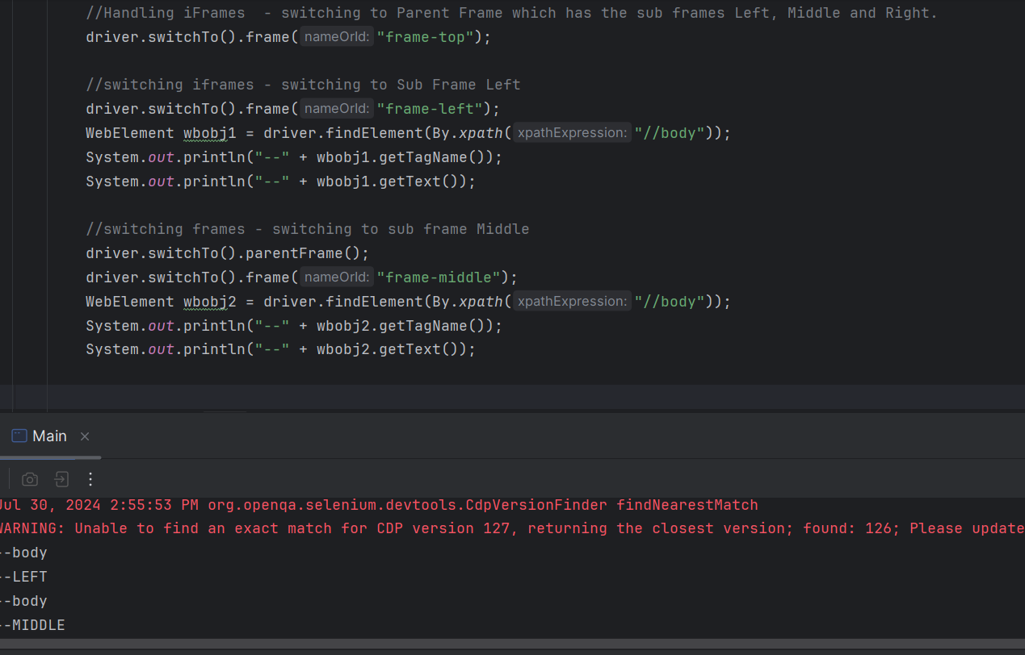

import io.opentelemetry.exporter.logging.SystemOutLogRecordExporter;  
import org.openqa.selenium.*;  
import org.openqa.selenium.edge.EdgeDriver;  
import org.openqa.selenium.interactions.Actions;  
import org.openqa.selenium.support.ui.Select;  
import org.openqa.selenium.support.ui.Wait;  
  
import java.time.Duration;  
import java.util.List;  
import java.util.Objects;  
import java.util.Set;  
import java.util.concurrent.TimeUnit;  
  
public class Main {  
 public static void main(String[] args) throws InterruptedException{  
 // Set the Path to Edge Driver.exe  
 System.*setProperty*("webdriver.edge.driver",  
 "C:\\Users\\axfel\\SeleniumANDtestNG\\Drivers\\msedgedriver.exe");  
  
 // Initialize the Drivers  
 WebDriver driver = new EdgeDriver();  
 Actions actobj = new Actions(driver);  
 JavascriptExecutor js = (JavascriptExecutor) driver;  
  
 //.get() = Opens the specified URL in the Browser type Initialized.  
 driver.get("https://the-internet.herokuapp.com/nested_frames");  
 Thread.*sleep*(3000);  
 driver.manage().window().maximize();  
  
  
  
 //Handling iFrames - switching to Parent Frame which has the sub frames Left, Middle and Right.  
 driver.switchTo().frame("frame-top");  
  
 //switching iframes - switching to Sub Frame Left  
 driver.switchTo().frame("frame-left");  
 WebElement wbobj1 = driver.findElement(By.*xpath*("//body"));  
 System.*out*.println("--" + wbobj1.getTagName());  
 System.*out*.println("--" + wbobj1.getText());  
  
 //switching frames - switching to sub frame Middle  
 driver.switchTo().parentFrame();  
 driver.switchTo().frame("frame-middle");  
 WebElement wbobj2 = driver.findElement(By.*xpath*("//body"));  
 System.*out*.println("--" + wbobj2.getTagName());  
 System.*out*.println("--" + wbobj2.getText());  
  
 Thread.*sleep*(3000);  
 driver.quit();  
  
 }  
}

Modal dialogs

There is no special methods to handle Model dialogs. Regular Xpath can be used to access the web elements inside the Modal dialog.

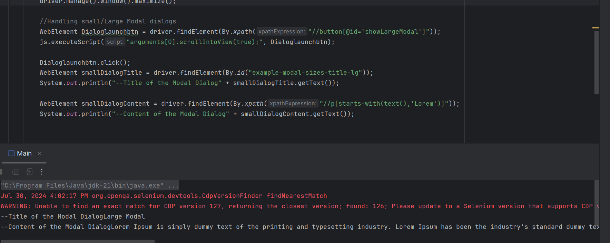

import io.opentelemetry.exporter.logging.SystemOutLogRecordExporter;  
import org.openqa.selenium.*;  
import org.openqa.selenium.edge.EdgeDriver;  
import org.openqa.selenium.interactions.Actions;  
import org.openqa.selenium.support.ui.Select;  
import org.openqa.selenium.support.ui.Wait;  
  
import java.time.Duration;  
import java.util.List;  
import java.util.Objects;  
import java.util.Set;  
import java.util.concurrent.TimeUnit;  
  
public class Main {  
 public static void main(String[] args) throws InterruptedException{  
 // Set the Path to Edge Driver.exe  
 System.*setProperty*("webdriver.edge.driver",  
 "C:\\Users\\axfel\\SeleniumANDtestNG\\Drivers\\msedgedriver.exe");  
  
 // Initialize the Drivers  
 WebDriver driver = new EdgeDriver();  
 Actions actobj = new Actions(driver);  
 JavascriptExecutor js = (JavascriptExecutor) driver;  
  
 //.get() = Opens the specified URL in the Browser type Initialized.  
 driver.get("https://demoqa.com/modal-dialogs");  
 Thread.*sleep*(3000);  
 driver.manage().window().maximize();  
  
 //Handling small/Large Modal dialogs  
 WebElement Dialoglaunchbtn = driver.findElement(By.*xpath*("//button[@id='showLargeModal']"));  
 js.executeScript("arguments[0].scrollIntoView(true);", Dialoglaunchbtn);  
  
 Dialoglaunchbtn.click();  
 WebElement smallDialogTitle = driver.findElement(By.*id*("example-modal-sizes-title-lg"));  
 System.*out*.println("--Title of the Modal Dialog" + smallDialogTitle.getText());  
  
 WebElement smallDialogContent = driver.findElement(By.*xpath*("//p[starts-with(text(),'Lorem')]"));  
 System.*out*.println("--Content of the Modal Dialog" + smallDialogContent.getText());  
  
 Thread.*sleep*(3000);  
 driver.quit();  
  
 }  
}

Authentication modal dialog

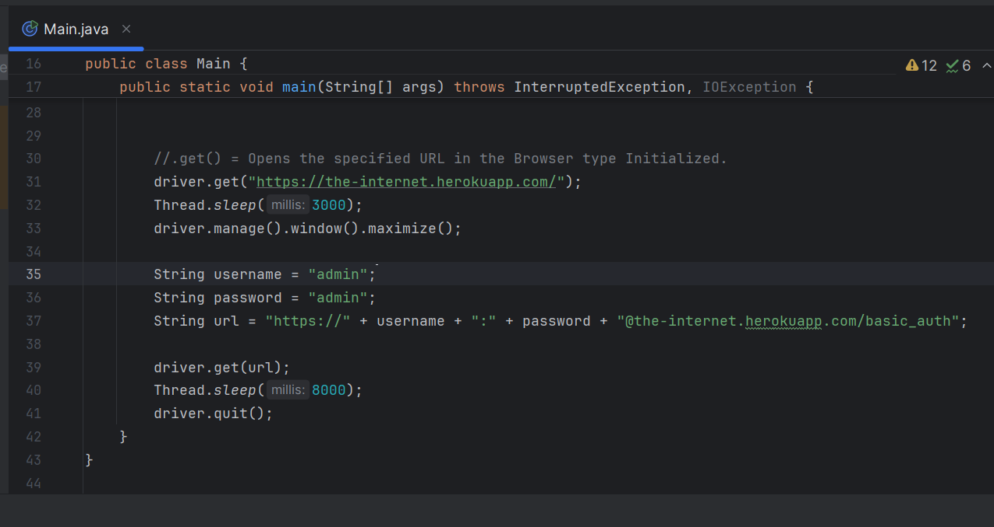

In the above case, “basic_auth” is the button which we need to click to get the autentication dialog. Hence basic_auth is added with Site URL is “[The Internet (the-internet.herokuapp.com)](https://the-internet.herokuapp.com/)” and the same is mentioned in the code.

This is just to clarify why /basic_auth is added in the URL.

To handle the authentication dialog, no need to click on the basic auth button, just add the basic_auth to the URL and execute the above code.

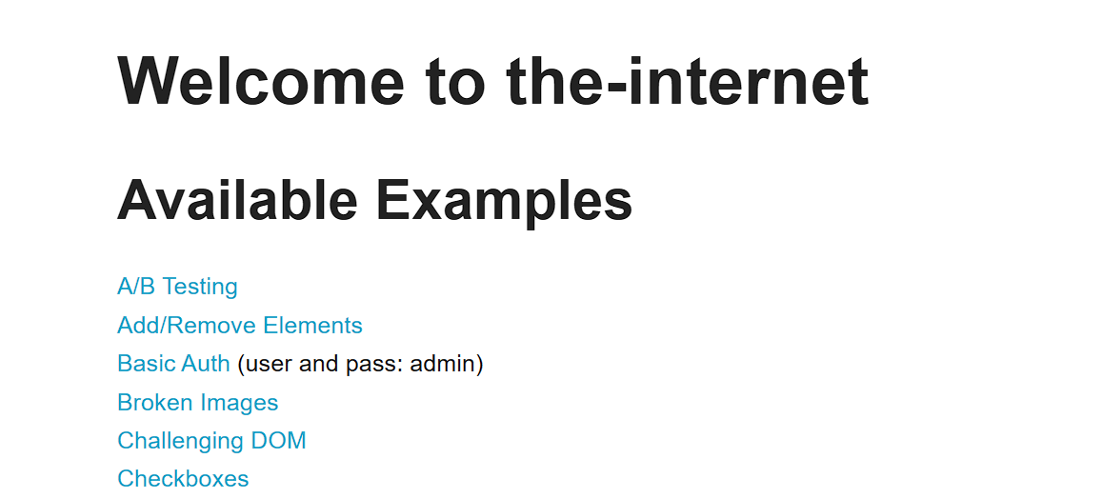

X-------------------------------EOF File------------------------------------X